Description of the grassland growth model LINGRA as implemented in CGMS

B.A.M. Bouman, A.H.C.M. Schapendonk, W. Stol & D.W.G. van Kraalingen

ab-dlo

July, 1996

Preface
This report documents the grassland growth model LINGRA (LINTUL GRAssland) developed by the DLO Institute for Agrobiology and Soil Fertility (AB-DLO) on request of the Joint Research Centre (JRC) of the European Communities at Ispra, Italy, in the framework of the MARS (Monitoring Agriculture with Remote Sensing) project. LINGRA was developed to predict growth and development of perennial rye grass across the member states of the EC at the level of potential production and water-limited production. In a joint project, AB-DLO, QRay-Agrimathica and the DLO Winand Staring Centre for Integrated Land, Soil and Water Research embedded LINGRA in the Crop Growth Monitoring System (CGMS) at JRC. The development and embedding of LINGRA took place between July 1995 and July 1996. This report gives an introduction to the goals of CGMS, an overview of its status quo before the embedding of LINGRA, and the specifications for the development of LINGRA (Chapter 1). Parts of this chapter were taken from Bouman et al. (1996). Chapter 2 presents a scientific explanation of the main principles of LINGRA. Chapter 3 introduces the data set that was used for calibration and evaluation of the model on experimental sites across Europe (3.1), and presents the results of the calibration (3.2) and evaluation (3.3). Technical specifications of the embedded LINGRA model, and an update of the user manual of CGMS are documented elsewhere (in prep). The appendices include a variable name listing (I), a listing of all input files (II), a listing of the model source code in Fortran (III), and an example of a data file of the grassland data base used for model calibration and evaluation.

The support of dr. P. Vossen from JRC to this project is kindly acknowledged. Special thanks are due to dr. A.J. Corrall and dr. J. Gilbey of IGER, Aberystwyth, who supplied us with the FAO data base with experimental data collected in the project “Predicting production from grassland’ in the framework of an FAO Subnetwork for lowland grassland. This data set proved invaluable for the calibration and evaluation of LINGRA on experimental sites across Europe.

Table of Contents
page

Preface
Table of Contents
Summary
1 Introduction. B.A.M. Bouman.
1.1 The Crop Growth Monitoring System (CGMS) 3
1.1.1 CGMS components
1.1.2 CGMS output
1.1.3 CGMS evaluated
1.2 Grassland production modelling: LINGRA
1.2.1 LINGRA in CGMS
1.2.2 CGMS LINGRA Output
2 Description of LINGRA. a.h.c.m Schapendonk, W. Stol, D.W.G. van Kraalingen, B.A.M. Bouman 11
2.1 Grass modelling
2.2 Special features of grass growth compared to arable crops
2.3 Model description
2.3.1 Initialization and cutting regime
2.3.2 Crop growth rate
2.3.3 Light interception
2.3.4 Light utilisation efficiency
2.3.5 Sink and source interaction
2.3.6 Leaf growth
2.3.7 Tillering rate
2.3.8 Transpiration
2.3.9 Crop development
2.3.10 Simulated output
2.4 Soil water balance

3 LINGRA parameterization and evaluation. W. Stol, B.A.M. Bouman, D.W.G. van Kraalingen, a.h.c.m Schapendonk.
3.1 Experimental data
3.1.1 The FAO-database
3.1.2 Selected data
3.2 Calibration
3.2.1 Calibration data
3.2.2 Model parameters for calibration
3.2.3 Calibration algorithm and performance criterion
3.2.4 Results
3.3 Evaluation
3.4 Overall evaluation and conclusion
References
Appendix I: variable name listing I
Appendix II: model input file II
Appendix III: Model listing III
Appendix IV: Example FAO data base file IV

Summary
This report documents the grassland growth model LINGRA (LINTUL GRAssland) developed by the DLO Institute for Agrobiology and Soil Fertility (AB-DLO) on request by the Joint Research Centre (JRC) of the European Communities at Ispra, Italy. LINGRA was developed to predict growth and development of perennial rye grass across the member states of the EC at the level of potential and water-limited production. The model is based on the LINTUL (Light INTerception and UtiLisation simulator) concept as proposed by Spitters (1987, 1989, 1990). The main principle of this concept is that crop growth is proportional to the amount of light intercepted by the canopy. LINGRA was developed using experimental data collected in greenhouses and from field trials conducted by AB-DLO in Wageningen, The Netherlands. The model was calibrated and evaluated on experimental field data collected throughout Europe in the project “Predicting production from grassland’ in the framework of a FAO Subnetwork for lowland grassland. The calibration resulted in two parameter value sets that accurately simulated observed biomass values in time of the harvestable product: a set for Northern Europe and a set for Southern Europe, with the geographic boundary between them running from West to East through the North of France, the South of Germany, Czechia, to the three-country border of Slovakia, Poland and Russia. The evaluation of LINGRA on an independent sub set of the data base indicated that the model predicted observed biomass values in time very well. The average error between observed and predicted biomass values, normalized to half of the observed biomass at the end of the growing season, averaged 13-15% on the level of potential production, and 17-21% on the level of water-limited production for the whole of Europe.

1 Introduction
B.A.M. Bouman

Timely and accurate crop yield forecasts on regional to (supra-)national scales are increasingly becoming important in developing and developed countries. Yield forecasts are defined here as the within-season estimates of what crop yield will be at the end of the growing season (as opposed to yield assessment of actually realised yields after harvest). In many developing countries, crop production forecasts have become an essential component of monitoring and warning systems for food security (Gommes, 1995). In Europe, the reforms of the Common Agricultural Policy of the European Union (EU) and the conclusion of the Uruguay round of the GATT discussions in 1994 are expected to lead to increased variation in agricultural production volumes and market prices. Therefore, policy makers, the commodity trade and transport industry need reliable and up-to-date information on expected yields and production volumes for their decision making. The most generally used methods so far for operational yield forecasting are based on empirical, statistical or sampling techniques. The empirical approach is based on obtaining evidence from subjective sources, such as expert judgements or farmer enquiries, e.g. as in The Netherlands (Kuipers, 1995). Statistical approaches use regression equations that express yield as function of various, mostly meteorological, yield determining factors, e.g. as for the whole of the EU by EUROSTAT (Palm & Dagnelie, 1993). Sampling methods are based on actual measurements of yield components in farmers fields, combined with statistical methods for processing the sampling data. Because samples are generally collected close to harvest time, they are more used for yield assessment after harvest than for actual forecasting, e.g. as in Baden Württemberg in Germany (Stadler, 1995). Recently, other methods for yield forecasting are being explored that are based on new and objective techniques such as simulation and systems analysis. For instance in the EU, a ten year project is underway at the Joint Research Centre for the improvement of agricultural statistics of its member states. This project, commonly known as MARS (Monitoring Agriculture with Remote Sensing) aims at, among others, the use of deterministic crop growth models, Geographic Information Systems (GIS) and remote sensing to forecast yield of the most important crops of its member states (Meyer-Roux & Vossen, 1994). At present, results of MARS are pre-operational and made available since 1993 (Vossen & Rijks, 1995). Reasons to explore new techniques for yield forecasting are that current methods used for forecasts suffer from a lack of consistency across regions and countries, are subjective in many cases, and are not delivered on time by all member states (Heath, 1990).

1.1 The Crop Growth Monitoring System (CGMS)
CGMS (Vossen, 1990; Vossen & Rijks, 1995) was developed for and implemented according to specifications provided by JRC of the European Commission under a contract by SC-DLO, assisted by AB-DLO and QRay-Agrimathica during 1990-1994. CGMS became operational at the JRC at Ispra (Italy) in 1994 as part of the Advanced Agricultural Information System of the MARS project. The function of CGMS is to monitor the agricultural season conditions over the whole of the EU with time intervals of ten days, and to make quantitative yield forecasts at national (NUTS-0) level. The crops currently addressed in CGMS (May, 1996) are sugar beet, potato, winter wheat, spring barley, grain maize, rice, field bean, soybean, oilseed rape and sunflower.

Figure 1.1. Schematic illustration of the components of CGMS (see text).

1.1.1 CGMS components
CGMS (Vossen, 1990; Vossen & Rijks, 1995) consists of three main components: a GIS, a set of data bases and a system-analytical part. The flow of data and operations are schematically illustrated in Figure 1.1.

GIS
The GIS part is the ARC/INFO geographical information system, around which user-interfaces were built for the manipulation of input and output data and to operate the system-analytical component.

Data bases
The data bases are built in ORACLE (RDBMS) and contain the input data needed by the system-analytical of CGMS. There are data bases on soil, weather, crop and yield statistics that cover the whole of the EU. The soil data base (King et al., 1994; Le Bas et al., 1994) contains information on available water capacity and soil depth, derived from the digital soil map of the EC (FAO classification, scale 1:1 million). The data are needed as input by the water-balance module of the crop growth model (see below). The weather data base (Burril & Vossen, 1995; Van der Drift & van Diepen, 1992) contains historic daily meteorological data over a period of 15 to 30 years for about 360 stations in the member states of the EU and adjacent countries. The weather data are directly used as indicators of progress of a current growing season, and as input for the crop growth model of the system-analytical component. The crop data base (Boons-Prins et al., 1994) contains information on crop calendars and crop characteristics needed as input for the crop growth model. Crop characteristics were derived for different locations in the EU from literature and by calibration of the crop growth model on experimental data sets. The yield statistics data base contains historical yield statistics from 1975 onwards, drawn from EUROSTAT's REGIO data base. These yield statistics are used in the statistical module of the system-analytical part of CGMS to calculate crop yield forecasts.

System-analytical part
The system-analytical part of CGMS consists of three modules: a meteorological module, a crop growth module and a statistical module.

The meteorological module (Meteoconsult, 1991) takes care of the processing of daily meteorological data that are received in real time from some 650 stations of the EU. First, it performs quality control, formatting and replacement of missing values. Second, derived parameters needed as input by the crop growth model or for the assessment of 'alarm' conditions are calculated, such as solar radiation (from cloud cover or sunshine duration), vapour pressure or potential evapotranspiration. Third, the data are interpolated to a regular grid of 50 x 50 km, representing spatial units of uniform weather conditions (Beek, 1991).

The crop growth module consists of the dynamic simulation model WOFOST (Supit et al., 1994; Van Diepen et al., 1989) in which crop growth and development are calculated from knowledge of the underlying physiological processes. In CGMS, model outputs related to crop growth are called crop indicators, e.g. biomass and Leaf Area Index (LAI). The paradigm in the use of WOFOST in CGMS is that agricultural production results from the interaction between weather, crop, soil and farming operations. Within a given region, crop and soil characteristics and farm management are relatively constant over years, and the function of WOFOST is to quantify the effect of varying weather conditions on crop growth. The working hypothesis is that real yields are influenced by weather in the same way as described by the crop model. The calculated crop indicators are related to two theoretical levels of production conditions: potential and water-limited production (De Wit & Penning de Vries, 1982). Potential production represents the absolute yield ceiling for a given crop in a given year on a given site, and is determined by solar radiation, temperature and crop characteristics. This ceiling can only be reached with a high input of fertilisers, irrigation (when needed) and pest, disease and weed control. Water-limited yield represents the yield ceiling without irrigation, where crop growth may be limited by rainfall during part of the growing season. For the water-limited situation, WOFOST contains a module for the calculation of the water balance of the soil. In CGMS, WOFOST is run on daily basis for each so-called 'simulation unit', i.e. unique combinations of weather, soil and crop (mapping) units.

In the Statistical module crop indicators calculated with WOFOST are related to historical yield statistics through a regression analysis in combination with a time-trend function, for at least 15 years of simulated and historical data (Vossen, 1992, 1995; Vossen & Rijks, 1995):

Statistical yield = α + β(Trend) + γ(Trend)² + δ(Crop Indicator) + error (1.1)

As factors in the regression serve the crop indicators 'total above ground dry weight' and 'dry weight storage organs'. Alternative or additional indicators can be Leaf Area Index, crop development stage, water use and soil moisture. When the addition of any of the crop indicators does not improve the regression analysis, only the time trend is used and δ = 0. The regression analysis is performed at the level of NUTS-0 and NUTS-1. The resulting regression equations per crop and per region serve as the actual forecasting algorithms.

1.1.2 CGMS output
CGMS generates on a decade and monthly basis three types of output on the current cropping season:
1. Maps of accumulated daily weather variables. These data are represented on grids of 50 x 50 km, and are used to follow the season's progress and detect any abnormalities, e.g. drought, frost ('alarm' indicators).
2. Maps of agricultural season quality indicators. Simulated crop growth indicators are compared with their long term means, and differences are evaluated in terms of more or less biomass than normal, or delayed or advanced phenological development. For this qualitative monitoring the indicators calculated at the level of simulation units are aggregated to grids of 50 x 50 km.
3. Tables of yield forecasts. The yield forecasts are made for NUTS-0 (country) and NUTS-1 (region) levels using the statistical module of the systems-analysis component. These yield forecasts become available well before the official regional yield figures are established by the various national agricultural statistical offices.

Results of CGMS are used operationally since 1993 in the preparation of the monthly MARS bulletins by JRC (Genovese, 1994). The objective of these bulletins is to inform readers on how the agricultural season in the EU is developing and to provide yield forecasts and acreage change estimations. The data presented in these bulletins are based on interpretations of CGMS data, satellite imagery, field surveys and expert knowledge. The main customers of the MARS bulletins are the EC's Directorate General for Agriculture and the European Statistical Office (EUROSTAT).

1.1.3 CGMS evaluated
Crop production is a complex process which takes place on farms at field level. Crop yields vary over regions, farms, fields, and years. Many different factors exert influence on the crop production process:
• Abiotic factors: e.g. soil water, soil fertility, weather;
• Farm management factors: soil tillage, planting density, sowing date, fertiliser application, crop protection measures, post harvest losses;
• Land development factors: field size, terracing, drainage, irrigation;
• Socio-economic factors: distance to markets, costs of inputs, prices of outputs, education level, skills, infrastructure.
Moreover, the influence of these factors may be completely overruled when the overall economic and political situation is unstable, or when crop-damaging catastrophes occur, by warfare, flooding, earthquakes, etc. The core of the CGMS system, i.e. the WOFOST crop growth model, considers mainly the abiotic factors, (but not all), so that actual yields may be determined by other factors not included in CGMS. In particular, socio-economic factors are completely ignored in the analysis of crop production conditions, while farm management factors are strongly generalised. A first evaluation of forecasted yields by CGMS took place in 1993, using CGMS version 1.1. This version did not yet include the soil data base, nor the aggregation module. The yields predicted by CGMS 1.1 and by 'conventional' regression techniques were compared with long-term yield statistics. The first results of this validation (De Koning et al., 1993; Vossen & Rijks, 1995) indicated that for most regions and most crops, interannual variability of crop yield was most accounted for by the technological trend. However, model outputs significantly contributed to multiple determination coefficients in approximately more than half of the crop x country combinations, as compared to the results obtained by using the trend only. This does not necessarily mean that in all those cases the prediction errors also significantly decrease (De Koning et al., 1993). It does mean, however, that in a large majority of cases, the system contributes to an improved monitoring and yield forecasting of annual crops, especially on the national scale, as compared to the use of time trend extrapolations alone. The actual user of CGMS, i.e. the JRC, also found additional benefits of the model approach that were not included in the scientific evaluation: CGMS predictions were timely (!), objective, quantitative, and consistent over large areas. Moreover, a number of options are open to improve the quality of the simulations by CGMS.

1.2 Grassland production modelling: LINGRA
In 1994, the ‘client’ of the MARS project, i.e. the European Commission and in particular EUROSTAT and DG VI (Agriculture), requested JRC to extend CGMS to include the estimation of productivity of grasslands. Therefore, a tender was issued with the objective to develop and test algorithms to extend the MARS project’s regional agrometeorological models to include estimation of biophysical production from forage and pasture grasses across Europe. The DLO Institute for Agrobiology and Soil Fertility (AB-DLO) together with QRay-Agrimathica and the DLO Staring Centre won the contract and started work in 1995. Together with JRC it was agreed to:
- Develop a dynamic simulation model for grassland productivity on the level of Potential production and Water-limited production
- Parameterize and evaluate the developed model on field experiments across Europe, using a common management scenario
- Incorporate the developed model into CGMS for operational application

Grasslands in Europe can be divided into two main systems:
Perennial rye grass, mostly found in Northwest Europe. In this system, grass is in dormancy during the winter period and starts (re-)growth with increasing temperatures in spring. Grasslands are either regularly mown, grazed (permanently or in rotation among fields) or have a combination of the two. Because of the mowing and/or grazing, these grasslands do generally not flower. The end of the season is determined by decreasing temperature or decreasing levels of radiation in autumn or winter.
Leys (natural annual grass), mostly found in Southern Europe and in Mediterranean countries. A mixture of seed is sown or emerges from fallen seed in the previous season in early spring, dependent on rainfall and temperature. Grass then grows to some 1.5 t dry matter/ha after which grazing starts. In general, grass goes through a complete life-cycle of emergence, vegetative growth, flowering, reproductive growth, seed filling and death.

Initially, it was suggested to develop simulation models separately for the two production systems, a model based on LINTUL (Spitters, 1990; Kooman, 1995) for perennial rye grass, and a model based on ARID CROP (Van Keulen, 1975) for leys. Both LINTUL and ARID CROP originate from the ‘School of de Wit’ crop growth models (Bouman et al., 1996). However, during the course of the project it became clear that no experimental data from southern European countries would be available for further development, parameterization and evaluation of ARID CROP for the ley systems (see Paragraph 3). Since, on the contrary, a large experimental data set became available for perennial rye grass across Europe, it was decided to concentrate efforts on building a LINTUL grassland model that would be valid for the whole of Europe. This has resulted in the model LINGRA (LINTUL GRAssland) (see Chapter 2).

1.2.1 LINGRA in CGMS
LINGRA was developed and written in the Fortran Simulation Environment (FSE 2.1; van Kraalingen, 1995) as developed over the years at AB-DLO especially for crop growth simulation modelling. The current crop growth model used in CGMS, WOFOST 6.0, was also written in this Fortran environment (Hijmans et al., 1994; Supit et al., 1994). FSE consists of a main program, a system for weather data input and utilities for specific tasks, such as input data reading and output writing. One of the main features of FSE is the distinction of four tasks that control the order of calculations in the program: ITASK = 1 for initialization; ITASK = 2 for rate calculations; ITASK = 3 for state calculations; and ITASK = 4 to mark the part of the program in which terminal calculations are done. For an understanding of the tasks of initialization and rate and state calculations, the reader is referred to text books on crop growth simulation modelling (e.g. Penning de Vries & Van Laar, 1982; Van Keulen & Wolf, 1986). FSE 2.1 makes use of the WEATHER system as described by van Kraalingen et al. (1990), and uses an updated version of the library TTUTIL as described by Rappoldt & Van Kraalingen (1990).

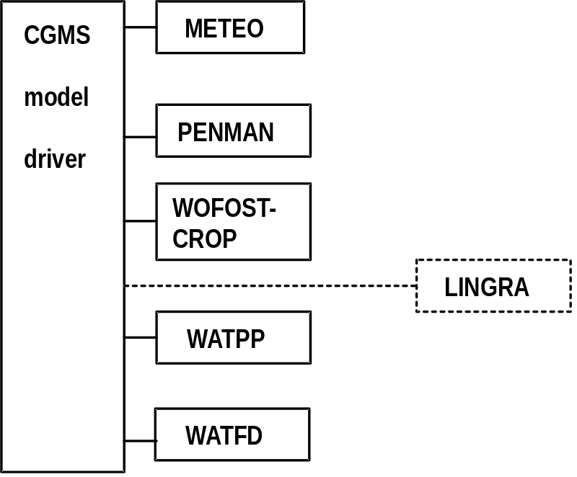

Figure 1.2. Schematic illustration of embedding LINGRA in the CGMS crop growth module. Solid line boxes are elements of the model driver of CGMS and of WOFOST, the dotted line box is the added LINGRA grassland model. METEO is the meteorological module; PENMAN calculates potential evapotranspiration; WOFOST-CROP is the crop growth routine of WOFOST; WATPP is a water balance for potential production situations; WATFD is the water balance for freely draining water-limited conditions (see also Supit et al., 1994).

Because both WOFOST and LINGRA were written in the FSE standard, implementation of LINGRA in CGMS followed the existing structure for WOFOST very closely. The ‘driver’ (TIMER), the weather system (METEO) and the Fortran utility library (TTUTIL) implemented for WOFOST were also used for LINGRA. Moreover, LINGRA uses the same evapotranspiration routine (PENMAN), the same water balance models, WATPP and WATFD, and the same input and output files as WOFOST (Figure 1.2). The technical details of implementation of LINGRA in CGMS, and a user manual of the ‘updated’ CGMS are published separately and are not part of this report.

1.2.2 CGMS LINGRA Output
LINGRA as implemented in CGMS produces output in the form of agricultural season quality indicators comparable to the ones produced by WOFOST (see Paragraph 1.1.2): simulated growth and development variables on the level of potential and water limited production (Table 1.1). In CGMS, LINGRA quantifies in a consistent manner the effects of weather on growth and development of a standard grassland, i.e. perennial rye grass, managed in a standard manner over the whole of Europe. The assumed standard management practice is: irrigated (potential production) or rainfed (water-limited production) perennial rye grass that is optimally provided with nutrients and optimally protected against yield limiting factors such as pests, diseases and weeds. The crop is mown at a fixed interval of four weeks starting at the beginning of the month of crop growth (though provisions are incorporated to change the mowing interval, or to apply mowing at pre-fixed biomass levels). In CGMS, the model LINGRA is always started at the first of January, and spring (re-)growth is initiated when mean daily temperatures have reached a critical, minimum level (see Chapter 2).

Table 1.1. Output of LINGRA in CGMS: agricultural season quality indicators at the level of Potential Production and Water-limited Production. See Chapter 2 for method of calculation.
 | Model abbreviation | Potential production | Water-limited production
Above ground biomass | TADRW | X | X
Yield | YIELD | X | X
Leaf Area Index | LAI | X | X
Development stage | DVS | X | X
Soil moisture | SM | not applicable | X
Total water requirement | TRAMXT | X | X
Total water consumption | CTRA | X | X

Actual yield forecasts (Paragraph 1.1.2) of grassland are not produced as output in CGMS because the statistical module that regresses simulated seasonal quality indicators against historical yield statistics has not been not adapted for grassland because of lack of grassland yield statistics.

2 Description of LINGRA
A.H.C.M. Schapendonk, W. Stol, D.W.G. van Kraalingen & B.A.M. Bouman

2.1 Grass modelling
The growth of crops obeys certain physiological principles. These may be described in qualitative terms but, to a certain extent, the various growth processes can also be quantified in response to the environment by mathematical equations. By linking the equations to each other, a mathematical model is obtained that, for convenience, can be written as a computer program. Such a quantitative model enables the prediction of crop growth rates and yields under a variety of environmental and management conditions. Models are useful as a tool for the farmer to assist in his decisions on management operations (e.g. in scheduling of irrigation, fertiliser application and crop protection). A crop model may also be used for land use evaluation or for yield forecasting as for instance in CGMS (see Chapter 1). For both purposes, two modelling approaches can be distinguished: a simple static model without description of process rates, and a dynamic model where state variables change in accordance to fluctuating process rates. Static models have the advantage of a small number of parameters and a simple algorithm. The dynamic approach, however, has the advantage of greater flexibility. In addition, it gives more insight into the sensitivity of underlying processes that interact with fluctuating climatic factors. This facilitates the extrapolation of effects on the individual organ level, established under constant conditions, to the level of a whole crop growing in an environment with fluctuating conditions. Various intermediate approaches are, of course, applicable, such as for instance in most generic models intended for regional applications. In such models, both static and dynamic descriptions are used. The LINGRA model is of such an intermediate type. It is derived from a model approach, later called LINTUL (Light INTerception and Utilisation simulator), proposed by Spitters (1987, 1989, 1990). The integration level is kept high and the number of processes has been restricted to key parameters only. Only a small number of processes involving these key parameters is simulated dynamically. On the other hand, parameters that have relatively little impact on crop growth, or of which knowledge is scarce, have been treated using the static approach. The additional advantage of using the LINTUL approach is that the number of model parameters is relativey low (compared to, for instance, WOFOST), which makes the model more easy to parameterize (Spitters, 1990).

For a thorough overview on the development of dynamic crop growth simulation models, the reader is referred to e.g. Penning de Vries & van Laar (1982), van Keulen & Wolf (1986), and Penning de Vries et al. (1989). Reviews on the various approaches followed in crop growth simulation and examples of their application have been given by, among others, Loomis et al. (1979), Penning de Vries (1983), Whisler et al. (1986), and Wisiol & Hesketh (1987), Spitters et al., (1989), and Bouman et al., (1996).

2.2 Special features of grass growth compared to arable crops
In contrast to arable crops, most grasslands are frequently defoliated due to herbivory
or management activities. The consequence of defoliation is reduction of photosynthesis rate. After defoliation, new leaves must be formed in order to assure continuation of production. These new leaves can only grow because significant amounts of carbohydrates were stored in the stubble of the plants before defoliation. These so-called ‘storage carbohydrates’ serve as a buffer that is emptied during a short period after cutting when photosynthesis is too small to provide for the necessary substances for regrowth. The reserves are replenished when light interception and photosynthesis rate are increasing again. Subsequent periods of defoliation and regrowth lead to an alternating sequence of temporary shortage of assimilates, just after defoliation, and a period of assimilate surplus at full light interception. These occurrences are characteristic for almost all grasses and must be accounted for in grass growth models. Assimilate demand and assimilate supply depend differently on environmental conditions. Assimilate demand (the sink) is strongly associated with leaf elongation, leaf appearance and tillering rate, whereas assimilate supply is controlled by photosynthesis and thus by the amount of light that is intercepted by the canopy. In LINGRA, the dynamic fluctuations of the assimilate demand (ΔW_{d}) and the assimilate supply (ΔW_{s}) are simulated semi-independently. The term ‘semi-independent’ is used because each day, crop growth rate is estimated from the most limiting process, either ΔW_{d} or ΔW_{s} as the driving rate variable. All other state variables are derived from the growth rate at that particular day and are not integrated independently for source and sink limitation.

2.3 Model description
LINGRA was developed on two hypothetical levels of production as defined by De Wit & Penning de Vries in 1982:
- Potential production. Growth occurs in conditions with ample supply of water and nutrients and growth rates are determined solely by weather conditions (solar radiation and temperature).
- Water-limited production. Growth is limited by shortage of water during at least part of the growing period but nutrients are in ample supply. Growth rates are determined by weather conditions (solar radiation, temperature, rainfall, potential transpiration) and by soil characteristics.
In both situations, the crop is optimally protected against pests, diseases and weeds. In the next paragraphs, the model statements on crop growth and development as implemented in LINGRA at these two levels of grass production are described.

The appendices give a variable name listing (I), a listing of example input files (II), and a listing of the model source code in Fortran (III).

2.3.1 Initialization and cutting regime
LINGRA runs with a defined set of initial parameter settings that are read from an external file. For instance initial leaf area, LAI_{c} (-), is set at a value of 0.1 and the storage pool present in the stubble after the winter period is 200 kg ha⁻¹. In principle, these parameter values can be changed by the user according to local field conditions; default values have been implemented in CGMS as derived from parameterization (Chapter 3).

Crop growth after the winter period is initialized when the 10-day moving average of daily temperature (actual conditions; particular year of simulation) is higher than a given base temperature Tb₁. When the temperature is lower than Tb₁ growth and development are set to zero.

In CGMS, a fixed cutting regime (read from external input file) is imposed that is the same for the whole of Europe: the crop is mown at the beginning of each month starting after spring (re-)growth and ending at winter dormancy. In principle, options have been implemented to change the cutting interval, or to make the time of cutting dependent on the accumulation of a certain amount of (above-ground) biomass. Leaf area index (LAI) is reset each time that the crop isdefoliated.The storage pool is dynamically simulated over the cuts according to the dynamic interactions between storage and remobilisation.

2.3.2 Crop growth rate
LINGRA (LINTUL GRASS) is based on the concept used in LINTUL (Light INTerception and Utilisation simulator; Spitters, 1987, 1988) that growth is proportional to the amount of light intercepted by the canopy:

DWt = ft . PARt . E_{t} (g m⁻² d⁻¹) (2.1)

where DWt is the growth rate at day t (g dry matter m⁻² d⁻¹), ft the fraction of PAR intercepted by the foliage, PARt the incoming amount of photosynthetically active radiation (MJ m⁻² d⁻¹), and E_{t} the light utilisation efficiency (g dry matter MJ⁻¹ PAR). PAR is the visible part of solar radiation (‘light’; wave bands 400-700 nm), and is about 50% of the total solar radiation (wave bands 300-3000 nm). The proportionality between crop growth rate and intercepted light has been recognized by many authors (Gaastra, 1958; Biscoe & Gallagher, 1977; Monteith, 1977), and the seemingly constancy of this proportionality factor has contributed much to its present popularity (review by Gosse et al., 1986). The calculation of total dry matter at the end of a growing season is simply obtained by integration of Equation 2.1 over time. The yield of the harvested product, Y (g dry matter m⁻²) can be calculated by multiplying total biomass (W) by the harvest index, HI (-), being the share of the harvested product in total dry matter:

Y = ∫ (f_{t} PAR_{t} . E_{t} ) HI (g m⁻²) (2.2)

In LINGRA, the harvest index is replaced by dynamic grass specific partitioning factors, intercepted radiation is calculated from leaf area index, and light use efficiency is made dependent on temperature, level of PAR and possibly occurring water stress. This has the advantage of replacing integrated quantities by variables defining instantaneous processes, i.e. replacing 'state variables' by 'rate variables'. In that way, it becomes easier to introduce the effects of stress conditions (Spitters & Schapendonk, 1989).

2.3.3 Light interception
The fraction of interception of photosynthetically active radiation by the grass canopy, ft (-), is calculated from the leaf area index, LAI (m² leaf surface m⁻² ground surface), and the extinction coefficient, k (-):

ft = (1-e^{(-k.LAI)}) (MJ m⁻²) (2.3)

The amount of intercepted radiation, PARint (MJ m⁻²), therefore becomes:

PARint = f_{t} . PAR_{t} = PAR (1- e^{(-k.LAI)}) (MJ m⁻²) (2.4)

The calculation of LAI is explained in Paragraph 2.3.6. The intercepted energy is used to assimilate CO₂ from the atmosphere by photosynthesis processes. The efficiency of light energy utilisation in photosynthesis processes is variable in time and dependent on the nutrient status and environmental conditions.

2.3.4 Light utilisation efficiency
The light utilisation efficiency, E_{t}, has a maximum value of 3 g MJ⁻¹ (called E_{max} ). Three factors affect the actual value of E_{t}: light intensity itself, temperature and water availability (in case of water-limitation).

Light intensity
The light utilisation efficiency is relatively high at low light intensities and declines at higher light intensities because photosynthesis follows a saturation curve. The effect of the daily integrated light intensity on the light dependent efficiency decline, called f(PAR) (-), is depicted in Figure 2.1. The light utilisation efficiency is constant at its maximum value below 5 MJ PAR and declines linearly above this threshold.

Temperature
Photosynthesis is activated above a certain temperature threshold, Tb₁ (°C). Thereafter, light utilisation increases linearly with temperature up to a maximum value at Tb₂ (°C), after which it remains constant with further increases in temperature (Figure 2.2). The factor that accounts for the effect of temperature on E_{t} is called f(T) (-). In Figure 2.2, the maxixmum temperature range is from -20 to 40 °C; temperature values outside this range have the same f(T) values as at these maximum values (i.e. no effects of extreme temperature values are taken into account).

Water availability
The rate of transpiration and of photosynthesis of the crop are dependent on the soil (water) suction on the one hand, and on the evaporative demand of the atmosphere on the other hand. When water is in shortage, soil suction increases and the plants close their stomata in order to prevent desiccation. When the stomata’s close, the uptake of CO₂ from the atmosphere is reduced and thus absorbed light is used less efficiently. This is formulated in the model by considering that the ratio of the actual transpiration, T_{a} (mm d⁻¹), over the potential transpiration, i.e. without water stress, T_{p} (mm d⁻¹), is a measure of the reduction of stomatal conductance and thus also of the reduction of photosynthesis and the light utilisation efficiency.

The factors light intensity, temperature and water stress are considered to have a multiplicative effect on maximum light utilisation efficiency, E_{max}, to result in the actual value, E_{t}:

E_{t} = T_{a}/T_{p} f(T) f(PAR) E_{max} (g MJ⁻¹) (2.5)

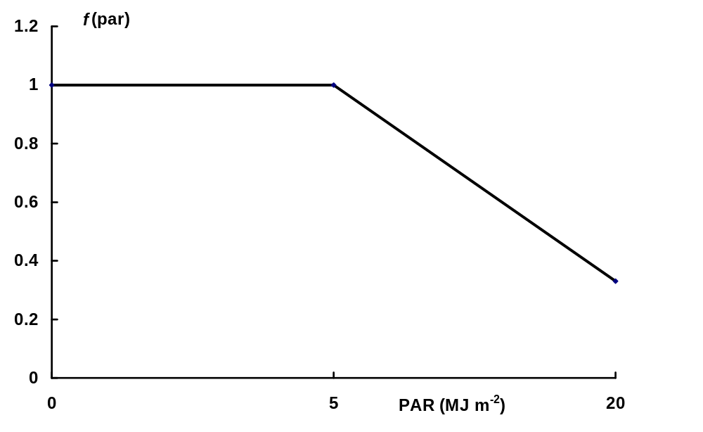
Figure 2.1 Multiplication factor on the light utilisation efficiency related to incoming PAR

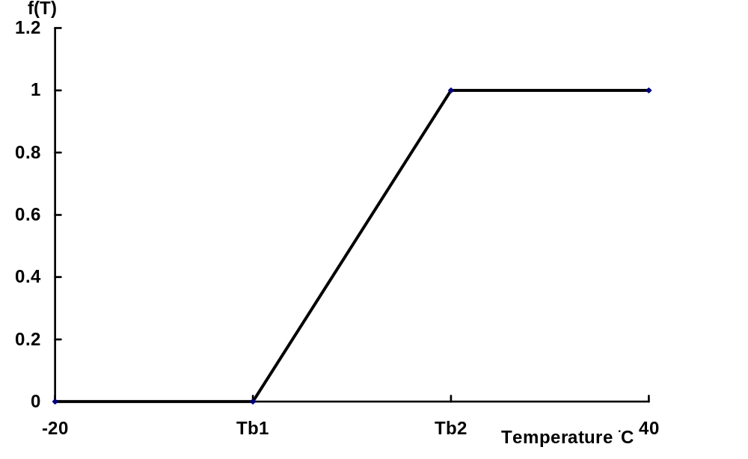
Figure 2.2 Multiplication factor on light utilisation efficiency as a function of temperature

2.3.5 Sink and source interaction
Total actual crop growth, ΔW (g d⁻¹), is determined by the balance between assimilate demand (sink), ΔW_{d}, and assimilate supply (source), ΔW_{s}. In the following, the subscript ‘d’ denotes the demand function, and the subscript ‘s’ denotes the supply function.

Assimilate demand
The main demand for assimilates comes from the growing leaves since leaf growth (after cutting) is crucial for the overall productivity of grasses because it dictates the amount of light that will be absorbed during the growth period. Initial, sink-limited, leaf growth is not limited by the supply of assimilates but by temperature. In LINGRA, initial growth of leaf area after cutting is described as the product of the number of tillers after cutting that have a node for leaf elongation, TIL _{n} (tillers m⁻²), the average width of new leaves, D_{lv} (m), and the leaf elongation rate ΔLV (m tiller⁻¹ d⁻¹):

ΔLAI_{d} = TIL _{n} D_{lv} ΔLV (m² leaf surface m⁻² ground surface d⁻¹) (2.6)

The number of tillers is determined from a special tiller routine (Paragraph 2.3.7); the average width of new leaves is a model parameter (i.e. 0.03 m), and the leaf elongation rate is described as a function of temperature, T (°C), (Spitters & Schapendonk, 1990):

ΔLV = 0,.0001 (ln( T) - 0.8924) (m² leaf surface m⁻² ground surface d⁻¹) (2.7)
When Tb₁ < T otherwise ΔLV = 0

In terms of biomass, sink limited leaf growth is calculated as

DWl_{v,d} = ΔLAI_{d} / ΔSLA (g m⁻² d⁻¹) (2.8)

where ΔSLA is the specific leaf weight of the newly formed leaves (m² leaf surface m⁻² ground surface g⁻¹).

Newly formed assimilates available for growth are partitioned between the leaves (above-ground biomass) and the roots (below-ground biomass). This partitioning between leaves and roots is independent from whether the growth is sink limited or source limited. Therefore, the total assimilate demand for (sink-limited) crop growth, ΔW_{d} is:

ΔW_{d} = DWl_{v,d} / f(lv) = (ΔLAI_{d} / ΔSLA)/ f(lv) (g m⁻² d⁻¹) (2.9)

where f(lv) is the fraction of assimilates that is partitioned to the leaves (-).

Assimilate supply
There are two sources of assimilate supply: the amount of assimilates fixed by photosynthesis during the day, P, and the reallocated assimilates from the amount of carbohydrates stored in the reserve pool (i.e. stubble), DW_{pool} (g).

ΔW_{s} = P + ΔW_{pool} (g m⁻² d⁻¹) (2.10)

The daily rate of photosynthesis is calculated as:

P = E_{t} PARint = PARint T_{a}/T_{p} f(T) f(PAR) E_{max} (g m⁻² d⁻¹) (2.11)

The amount of assimilates that is available for reallocation from the reserve pool is derived from the available amount and the balance between daily assimilate demand and supply (see below).

Actual growth rate
Actual total crop growth rate, ΔW, is the minimum of the assimilate demand and the assimilate supply:

ΔW = minimum(ΔW_{d} , ΔW_{s}) (g m⁻²d⁻¹) (2.12)

Thus, growth takes only place when the supply (photosynthesis plus reallocation from the reserve pool) exceeds or equals the demand function. Conversely, carbohydrates will be stored in the reserve pool when the photosynthetic supply exceeds the demand:

ΔW_{pool} = ΔW_{s} - ΔW_{d} (g m⁻²d⁻¹) { when ΔW_{s} > ΔW_{d}}} (2.13)

In general, the carbohydrate demand will be relatively high during the first days after defoliation because photosynthesis is low and the crop requires carbohydrates for regrowth of the leaves.

2.3.6 Leaf growth
Actual leaf growth is derived from the amount of assimilates available for growth and the death rate of leaves by senescence. The increase in leaf area from assimilate availability is calculated from the actual daily crop growth rate (see Paragraph 2.3.4). Net leaf growth, ΔLAI (m² leaves m⁻² surface d⁻¹), is therefore:

ΔLAI = f(lv) ΔW ΔSLA - ΔDLAI (m² leaf surface m⁻² ground surface d⁻¹) (2.14)

The death rate of leaves is calculated from a relative death rate, RDR (d⁻¹):

ΔDLAI = LAI (1-e^{(-RDR t)}) (m² leaf surface m⁻² ground surface d⁻¹) (2.15)

where t = time (d).

The relative death rate of leaves is affected by internal shading and by water stress (Spitters & Schapendonk, 1990).

Shading
With increasing LAI, the deeper layers of the crop become shaded. The low light intensities initiate remobilisation of nitrogen from the shaded leaves and these leaves go through a stage of rapid senescence. The variation of the magnitude of relative death rate of leaves due to internal shading, RDR_{lsh} (d⁻¹), as function of LAI is given in Figure 2.3.

Water availability
Senescence is also promoted by water shortage, probably by hormonal interactions. The variation of the magnitude of relative death rate of leaves due to water shortage, RDR_{lsh} (d⁻¹), as function of the ratio of actual over potential transpiration, T_{a}/T_{p}, is given in Figure 2.4.

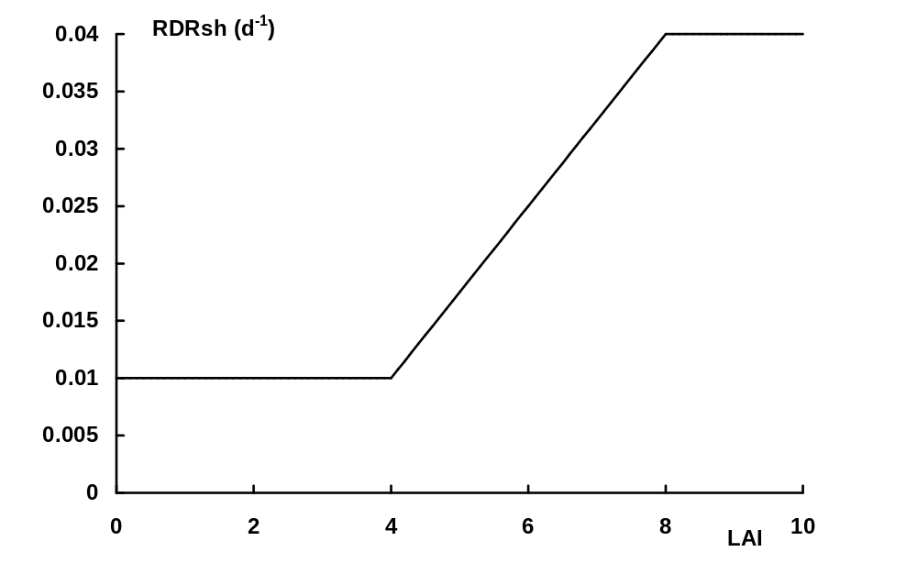
Figure 2.3. Relative death rate of leaves due to internal shading as a function of LAI.

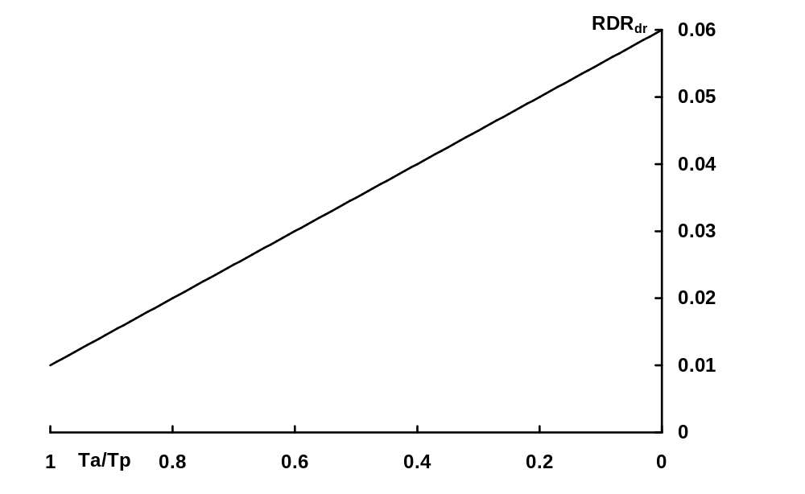
Figure 2.4. Relative death rate of leaves due to water shortage as a function of the ratio T_{a}/T_{p}.

The total relative death rate of leaves is calculated as the sum of a basis death rate and a death rate caused by internal shading and water shortage. The basic relative death rate is 0.01 (d⁻¹). The effects of internal shading and water shortage are not additive, and the overall effect is taken to be the maximum value of RDR_{sh} and RDR_{dr}. Total RDR is thus calculated as:

RDR = 0.01 + maximum (RDR_{sh}, RDR_{dr}) (m² leaf surface m⁻² ground surface d⁻¹) (2.16)

2.3.7 Tillering rate
In general there is a very close correlation between the formation of tillers and the productivity of grasses (Schapendonk & de Vos, 1988). Each tiller produces new leaves and in principle each axil of a leaf contains a bud to produce new tillers. The maximum number of tillers emerging from new buds is 0.69. Just after mowing this number is much less, i.e. 0.335. This cascade of events is sensitive to light, temperature and stress conditions. Internal shading was already mentioned as a factor that promotes senescence but it also induces tiller death and it prevents the formation of new tillers from buds.

The increase in number of tillers, ΔTIL_{n} (tiller m⁻² d⁻¹), is related to the appearance rate of new leaves, ΔLEAF_{n}, (leaf leaf⁻¹ d⁻¹) and to the sum of the relative rate of tillering, RTR (tiller tiller⁻¹), and relative tiller death rate, TDR (tiller tiller⁻¹), times the amount of tillers (tiller m⁻²):

ΔTIL_{n} = ΔLEAF_{n} TIL_{n} (RTR - TDR) (tillers m⁻² d⁻¹) (2.17)

The appearance rate of new leaves is closely related to soil temperature. From data of Davies & Thomas (1983), a simple relation for leaf appearance rate is given by:

ΔLEAF_{n} = Tsoil 0.01 (leaf leaf⁻¹ d⁻¹) (2.18)

Relative tillering rate
Relative tillering rate, RTR, is different in the first week after (periodic) cutting from the period after. In both periods, RTR is a function of LAI, modified by an effect of temperature. In the first week after cutting the relative tillering rate is given by (Van Loo, 1993):

RTR = (0.335 - 0.067 LAI) * f(T) (tiller tiller⁻¹) (2.19)

where f(T) is the same as the multiplication factor on light utilisation efficiency as function of temperature (Figure 2.2).

One week after cutting, RTR is calculated as:

RTR = (0.867 - 0.183 LAI) f(T) (tiller tiller⁻¹) (2.20)

with a maximum value of 0.69.

Tiller death rate
Tiller death rate, TDR, is affected by temperature sum, Tsum (°C) and by LAI.

TDR_{Tsum} = 0.01 (1 + Tsum/600) (tiller tiller⁻¹) (2.21)
TDR_{LAI} = 0.05 (LAI - 4)/ 4 (tiller tiller⁻¹) (2.22)

The temperature sum, Tsum, is the integrated daily average temperature minus the base temperature Tb₁ (see Paragraph 3.2.1).

The effects of temperature sum and LAI are not additive, and the overall effect is taken to be the maximum value of TDR_{Tsum} and TDR_{LAI}. Total TDR is thus calculated as:

TDR = maximum (TDR_{Tsum}, TDR_{LAI}) (tiller tiller⁻¹) (2.23)

2.3.8 Transpiration
Potential evaporation and crop transpiration was calculated using the Penman formulations as implemented in subroutines of the WOFOST model (i.e. EVTRA, PENMAN; Hijmans et al., 1994; Supit et al., 1994). In the Penman formulations, potential evapotranspiration is calculated for a water surface, E₀ (cm d⁻¹), bare soil, E_{S0} (cm d⁻¹), and a reference crop, E_{T0} (cm d⁻¹), from daily weather variables (radiation, temperature, wind speed and vapour pressure). Potential transpiration of grass, E_{TC} (cm d⁻¹) is the same as that of the reference crop:

E_{TC} = Kc E_{T0} with Kc = 1. (cm d⁻¹) (2.24)

where Kc is a crop specific correction factor on potential transpiration rate. E_{TC} is the value of potential transpiration of a crop with complete ground cover (large LAI) and with optimum supply of soil water. With incomplete ground cover, the potential transpiration rate is reduced according to its LAI (T_{p}):

T_{p} = E_{TC} (1-e^{(-0.75 Kdif LAI})) (cm d⁻¹) (2.25)

where Kdif is the extinction coefficient for total global radiation.

The transpiration rate of crops drops below the potential value when water shortage in the root zone occurs. The ratio between the actual transpiration rate, T_{a}, and the potential transpiration rate, T_{p}, is given by:

T_{a}/T_{p} = ( V_{act} - V_{wp} ) / ( V_{cr} - V_{wp}) (-) (2.26)

where V_{act} is the volumetric water content in the rooting zone, V_{wp} is the volumetric soil water content where wilting begins, and V_{cr} is the critical volumetric soil water content below which transpiration decreases (see Hijmans et al., 1994; Supit et al., 1994).

The volumetric soil moisture content in the root zone is calculated by separate water balance routines that operate independent from LINGRA. In CGMS, the models WATPP and WATFD are used for potential production and water-limited production situations respectively. See Hijmans et al. (1994) and Supit et al. (1994) for details on these water balance routines.

2.3.9 Crop development
In Perennial rye grass, the crop does not fulfil a natural growth cycle such as emergence, vegetative stage, flowering, generative stage, ripening and death such as grass in the ley systems or annual crops such as cereals. The frequent cutting and/or grazing of the crop suppresses this development. Therefore, in LINGRA, no development stage is modelled that has specific relations to phenological development of the crop. To ‘mimic’ the simulation of crop development for comparison of earliness between different sites and seasons (and for compatibility with WOFOST), however, a development stage, DVS (-), was introduced as fraction of a temperature sum of 600 °C:

DVS = Tsum / 600 (-) (2.27)

where Tsum (°C) is temperature sum since the start of spring (re-)growth. A similar approach is followed to mimic a phenological development stage in WOFOST for crops such as sugar beet (Hijmans et al., 1994; Supit et al., 1994).

2.3.10 Simulated output
The output of LINGRA in CGMS as given in Table 1.1 (Paragraph 1.2.2) is related to the symbols used in the previous paragraphs as follows, Table 2.1:

Table 2.1. Relation between LINGRA output variables names in CGMS and symbols used in the scientific model description. Note: the method of calculation has been included when this was not explained in the text.
 | Model abbreviation | Symbol used/ calculation
Above ground biomass | TADRW | W_{lv}
Yield | YIELD | W_{lv} - W_{pool}
Leaf Area Index | LAI | LAI
Development stage | DVS | DVS
Soil moisture | SM* | V_{act} *
Total water requirement | TRAMXT | ∫T_{p}
Total water consumption | CTRA | ∫T_{a}
*: output from water balance routine WATFD of WOFOST in CGMS (see Paragraph 2.4)

2.4 Soil water balance
The soil water balances coupled to LINGRA in CGMS are the same as used for the WOFOST model (see also Paragraph 1.2.1): WATPP for potential production and WATFD for the water-limited production situation (Hijmans et al., 1994; Supit et al., 1994).

WATPP is in fact not a true water balance since it does not keep track of water flow in a soil layer. Instead, for the simulation of crop production without water stress, WATPP consists of a statement that keeps the water content of the (rooted) soil permanently at field capacity:

V_{act} = V_{fc} (-) (2.28)

where V_{act} is the volumetric water content in the rooting zone, V_{fc} is the volumetric soil water content at field capacity.

WATFD is a water balance of the so-called ‘tipping bucket’ type, applicable to freely draining, sandy and loamy soils with a deep ground water table (> 1 m below the root zone; so that capillary rise from the ground water into the root zone does not occur). This type of soils has high hydraulic conductivity when wet, permitting fast downward water transport so that saturation of soil layers does not occur. The model can also be used for clayey soils with deeper groundwater table (> 2m below root zone), but the simulations are then more crude. The model is not suitable for (heavy) clay soils with impeded drainage. In WATFD, the water content in the soil, V_{act}, is tracked for the rooted zone with time steps of one day. Because the rooted depth is considered to be homogeneous in texture, there is no subdivision into different soil layers (1-layer model). The water balance processes considered are infiltration from precipitation (and any added irrigation water), evaporation from the surface, and water uptake by the crop (via transpiration). If rainfall intensity exceeds the maximum rate of infiltration and the surface storage capacity, water runs off. The infiltrating amount of water is added to the actual soil water content in the rooted zone, and water loss by surface evaporation and by crop transpiration is subtracted. Water can be stored in the rooted depth until field capacity is reached. Any excess water over field capacity is percolated down the rooted depth and considered as ‘lost’. Upward water flow (capillary rise) is disregarded and lateral influx or outflux of water is not considered. A detailed description of the calculation statements of WATFD is given by Supit et al., 1996.

3 LINGRA parameterization and evaluation
W. Stol, B.A.M. Bouman, D.W.G. van Kraalingen & A.H.C.M. Schapendonk

3.1 Experimental data
A list was drawn of contacts of AB-DLO to be asked for experimental data of grassland suitable for model development, calibration and evaluation. This list, complemented by IRSA-JRC for East-European and Mahgreb countries, held in total 34 persons and institutions that are working in the field of grassland production and agronomy. Each of these persons or institutes were contacted by mail and asked to be involved in this project by making experimental data and developed model code mutually available. On basis of the reactions to this enquiry, 14 more detailed requests were send. Three data sets were eventually obtained that were, in principle, suitable for model development, calibration and evaluation: one from Poland, one from Sweden and an extensive data set covering the whole of Europe that was set up by FAO. Because of the consistency with which data were collected, processed and stored in a digital data base, calibration and evaluation activities concentrated on the use of the FAO data base.

3.1.1 The FAO-database
A database with production data of grassland was produced within the framework of an FAO Subnetwork for lowland grassland by the project “Predicting production from grassland’. This project started in 1980 when a proposal submitted by Dr. A.J. Corrall of the Grassland Research Institute at Hurley, UK, was adopted by the members of this FAO Subnetwork. The aim of the project was to improve knowledge of the potential for forage production from cultivated grassland throughout the temperate climatic zone. The project was adopted by 35 members of the network, who conducted standardised experiments of grass production throughout the growing season for three to five years on sites with different climatic and soil conditions (Corrall, 1984, 1988). The resulting database contains experimental data on common grassland experiments using two standard cultivars of Lolium Perenne (perennial rye grass) and Phleum pratense (Timothy), respectively cv.’s Cropper and Kampe II, together with data on observed meteorological variables. The field experiments in their full layout included a rainfed, non-irrigated and an irrigated treatment. However, not all members of the network included both grass species and both treatments in their experiment. In the Northern countries, only Timothy was sown whereas in the Southern countries, the perennial rye grass variety was preferred. Experimental observations were conducted each year on grasslands that were newly sown in the year before. Measured crop production rates therefore hold for grasslands of a standard age, i.e. the first full harvest year. In general, the effect of ageing on grass production can be neglected since all used experimental data have the same - for forage production favourable - point of departure. For a limited number of sites, however, observations are available of both the first and the second year after sowing. Grasslands were fertilised with weekly applications following a standard procedure that was designed to ensure as far as possible that growth was never inhibited by nutrient deficiency. The experimental layout covered four harvest times on plots within the fields, in two replicates, per treatment (thus totalling 8 plots per treatment). Two plots of each treatment were periodically harvested on a four week interval from April 1st onwards till grass growth ceased in autumn. Countries in the south of Europe started somewhat earlier with the monitoring of crop production, while in the northern countries, the observations started later in the year. The original experimental observations were processed in a standardized manner before inclusion in the FAO data base. On the basis of measured data of four series of plot cuts in sequence, estimates of the weekly rate of dry matter accumulation were calculated. With this procedure, weekly and seasonal crop growth rates were derived, thus averaging out effects of timing of harvests on production of forage. This use of several series of overlapping harvesting sequences produced an annual production pattern which might be considered as the average to be expected from the harvesting sequences within a system of rotational grazing rather than a pattern unique to one specific set of harvest dates (Corrall & Fenlon, 1978; Corrall et al., 1979). Next to the processed crop variables, meteorological data were stored in the data base on weekly basis.

To enable the use of the data in the FAO-database for calibration and evaluation of the LINGRA model, a conversion program called FAOGRASS was developed to convert the experiment files in the database to files that could directly be used within the FORTRAN Simulation Environment of van Kraalingen (1995), see Paragraph 1.2.1. Weather data extracted from the database were quality checked, and, where needed, revised. An example of an experimental observation file (f3084obs.dat) and a corresponding weather data file (gbr76.984), belonging to the experiment carried out at North Wyke in the UK in 1984 is given in Appendix IV.

3.1.2 Selected data
Table 3.1 gives an overview of the experimental data of the FAO data base that were used for calibration and evaluation of LINGRA. The location of the experimental sites is given in Figure 3.1.
For LINGRA, only experimental data on perennial rye grass are relevant and only these data were selected from the data base. Data of experiments that had missing observations on harvests, or that had weather data that could only be used after major revision were rejected. The same holds for data that were considered ‘suspicious’ because of unexplained large deviating behaviour (large variation in observed dry matter production across years while variation in measured radiation and temperature across years was small; however, only one site was rejected because of this reason). From those sites that had monitored forage production both in the first and in the second full harvest year after sowing, only the data of the first year after sowing were used.

Figure 3.1. Site location of experiments in the project “Predicting production from grassland’ of the FAO Subnetwork for lowland grassland, as stored in the FAO data base. The numbers of the locations correspond with the site numbers given in Table 3.1. The drawn line is the boundary between the Northern and the Southern grassland variety as derived from calibration of LINGRA (Paragraph 3.2.4)
Table 3.1. Overview of experimental data of the FAO data base that were used for calibration (marked with *) and evaluation of LINGRA.

Country | Experimental site | Site no. | Year | Final yield  Irrigated  (kg dm/ha) |  | Final yield  Non-irrigated  (kg dm/ha) | Data set used for Calibration
Belgium | Michamps | 22 | 1984 | 12940 | 13000 |  | -
Belgium | Michamps | 22 | 1985 | 12770 | 12850 |  | -
Eire | Grange | 7 | 1982 | - | 16330 |  | *
Eire | Grange | 7 | 1984 | - | 15800 |  | *
Eire | Moorepark | 8 | 1982 | - | 16330 |  | *
England (UK) | North Wyke | 30 | 1983 | 12690 | 9790 |  | -
England (UK) | North Wyke | 30 | 1984 | 13670 | 9890 |  | -
England (UK) | North Wyke | 30 | 1985 | 11570 | 11610 |  | -
France | Bourg-Lastic | 16 | 1983 | - | 9630 |  | -
France | Bourg-Lastic | 16 | 1984 | - | 9350 |  | -
France | Bourg-Lastic | 16 | 1985 | - | 7745 |  | -
France | Bourg-Lastic | 16 | 1986 | - | 6210 |  | -
France | Rennes | 17 | 1984 | 15350 | 12970 |  | *
France | Rennes | 17 | 1985 | 13320 | 8930 |  | -
Germany | Braunschweig | 1 | 1983 | - | 10230 |  | -
Germany | Braunschweig | 1 | 1984 | - | 13150 |  | -
Germany | Braunschweig | 1 | 1985 | - | 9980 |  | -
Germany | Braunschweig | 1 | 1986 | - | 12760 |  | -
Germany | Kiel | 26 | 1984 | - | 14480 |  | -
Germany | Kiel | 26 | 1985 | - | 19700 |  | -
Italy | Carmagnola | 27 | 1983 | 16480 | 14430 |  | *
Italy | Carmagnola | 27 | 1984 | 15010 | 14310 |  | -
Italy | Lodi | 28 | 1983 | 14820 | 11880 |  | *
Italy | Lodi | 28 | 1984 | 14670 | 11330 |  | -
Italy | Lodi | 28 | 1985 | 12110 | 6970 |  | -
N. Ireland (UK) | Crossnacreevy | 5 | 1982 | 18710 | 17230 |  | *
N. Ireland (UK) | Crossnacreevy | 5 | 1983 | 15300 | 16120 |  | *
N. Ireland (UK) | Crossnacreevy | 5 | 1984 | 18240 | 17320 |  | *
Netherlands | Wageningen | 2 | 1983 | 15490 | 11430 |  | -
Netherlands | Wageningen | 2 | 1984 | 11620 | 10490 |  | -
Netherlands | Zegveld | 31 | 1984 | 17690 | 16480 |  | *
Netherlands | Zegveld | 31 | 1985 | 17800 | 17620 |  | *

Table 3.1 continued.
Country | Experimental site | Site no. | Year | Final yield  Irrigated  (kg dm/ha) | Final yield  Non-irrigated  (kg dm/ha) |  | Dataset used for Calibration
Norway | Saerheim | 20 | 1984 | - |  | 11220 | -
Norway | Saerheim | 20 | 1985 | - |  | 11000 | -
Rumania | Cluj-Napoca | 19 | 1986 | 12720 |  | 8600 | *
Rumania | Suceava | 18 | 1983 | - |  | 9640 | -
Scotland (UK) | Auchincruive | 23 | 1983 | - |  | 12960 | -
Scotland (UK) | Auchincruive | 23 | 1984 | - |  | 9830 | -
Scotland (UK) | Auchincruive | 23 | 1985 | - |  | 14160 | -
Scotland (UK) | Auchincruive | 23 | 1986 | - |  | 12300 | -
Scotland (UK) | MacRobert | 14 | 1983 | - |  | 11180 | -
Scotland (UK) | MacRobert | 14 | 1984 | - |  | 12260 | -
Scotland (UK) | MacRobert | 14 | 1985 | - |  | 16960 | -
Scotland (UK) | MacRobert | 14 | 1986 | - |  | 15010 | -
Spain | La Coruna | 24 | 1983 | 17569 |  | 14007 | *
Spain | La Coruna | 24 | 1984 | 16460 |  | 13500 | -
Spain | La Coruna | 24 | 1985 | 14920 |  | 12090 | -
Switzerland | Changins | 13 | 1983 | 14430 |  | 11870 | *
Switzerland | Changins | 13 | 1984 | 18910 |  | 11880 | *
Switzerland | Changins | 13 | 1985 | 15310 |  | 11330 | -
Yugoslavia | Krusevac | 21 | 1984 | - |  | 6520 | -

3.2 Calibration
The purpose of model calibration was to find parameter values that resulted in the best fit between simulated and observed grass production at all sites across Europe. Different parameter values can be allowed for different locations in Europe when this contributes to a better match between simulations and observations at those locations. In the current version of CGMS, sets of regional-specific parameter values for arable crops as modelled with WOFOST are considered to represent different varieties, and are therefore termed ‘variety parameters’. In the case of grassland as modelled with LINGRA, however, sets of different parameter values do not correspond to different varieties (since the same variety was used in the common experiments of the FAO data base), but express effects of environmental conditions that are not accounted for in the model. For compatibility between LINGRA and WOFOST, the term ‘variety specific’ parameter set is used here too.

European-wide calibration of LINGRA, with the provision to allow for different parameter value sets for different locations, was an interactive procedure between calibration and evaluation. The results of this calibration were ‘variety’ parameter sets with their geographic boundaries of applicability.

3.2.1 Calibration data
LINGRA was calibrated on the level of potential production only. The lack of information on soil characteristics and observations on the water balance of the soils during the experiments inhibited the calibration of LINGRA at the level of water-limited production. Moreover, a calibration of LINGRA at the level of water-limited production would entail a calibration of the water balance model WATFD which fell outside the scope of this project. For calibration on the level of potential production, only irrigated treatments were selected and non-irrigated treatments where rainfall was sufficient to ensure non-stressed growth (i.e. the Eire and N. Ireland sets in Table 3.1).To simulate the theoretical level of potential production, only data sets were accepted from experiments that approached unrestrained growth. In total 15 experiments were selected that showed seasonal dry matter yields close to or above 15-16 ton dry matter per hectare (Table 3.1), with the exception of Cluj-Napoca in Rumania and Changins in Switzerland that had lower yield levels. Considering the mowing interval of four weeks, it may be assumed that these crops were grown under near potential production situation (Baan-Hofman, personal communication). By selection of the water-balance WATPP that keeps the soil moisture content at optimum levels for crop growth during the whole growing season (Hijmans et al., 1994; Supit et al., 1994), no drought stress conditions occurred during simulation with LINGRA.

The subset for calibration was selected in such a manner that a sufficiently large set remained for independent evaluation of the (calibrated) model (Paragraph 3.3).

3.2.2 Model parameters for calibration
From model evaluation and sensitivity analysis, four parameters were selected for calibration (Table 3.2):

Table 3.2. LINGRA parameters (symbol, abbreviation and explanation) used for calibration. The symbols given correspond to the ones given in the model description in Chapter 2.
Symbol | Abbreviation | Explanation
Tb₁ | TMBASE1 | Minimum threshold temperature for photosynthesis (°C)
Tb₁ | TMBASE2 | Threshold temperature after which photosynthesis reaches a maximum value (°C)
LAI_{c} | CLAI | Leaf area index after cutting (m² leaf surface m⁻² ground surface)
E_{max} | LUEMAX | Maximum light use efficiency (g MJ⁻¹ )

The parameter TMBASE1 determines the moment of onset of growth of the crop. In the model, TMBASE1 acts as lower limit for dry matter accumulation. If soil temperature, estimated by the 10-day moving average day temperature (actual conditions; particular year of simulation), exceeds the value of TMBASE1, accumulation of dry matter, although still reduced by temperature (Figure 2.2; Eq. 2.6), starts. The parameter TMBASE2 determines the point where temperature does not reduce dry matter accumulation anymore (Figure 2.2). In essence, these two parameters together determine the response of intercepted radiation by the crop on dry matter accumulation in spring and autumn when temperatures are suboptimal for crop performance.

The parameter CLAI determines the leaf area index after cutting of the grass, and therewith also the remaining amount of crop biomass. Low values of CLAI (short cutting heights) increase the period of sink-limited leaf and crop growth after cutting and reduce dry matter accumulation. By adapting the value of CLAI, model behaviour can be made more or less sensitive for partial light interception after cutting.

LUEMAX, is the maximum efficiency at which intercepted photosynthetic active radiation is converted in dry matter (Eq. 2.6). Its value can be derived from the crop growth curve plotted against accumulated absorbed radiation in the phase of linear growth.

The default values for these four parameters were derived during model development using greenhouse and field experiments of AB-DLO carried out at Wageningen, The Netherlands (see also Table 3.3 below)

3.2.3 Calibration algorithm and performance criterion
To assess the goodness of fit of the model with respect to experimental data, an optimisation procedure for calibration of crop growth models has been used, called FSEOPT (Stol et al., 1992). This procedure contains a controlled random search (CRS) algorithm, adapted from Price (1976), for finding the global minimum of a function with constraints on the independent variables. The algorithm can be visualised as consisting of two parts; the first being non-iterative while the second is iterative. In the first part a number of parameter sets are generated consisting of parameter values chosen at random from biologically plausible ranges around the nominal values of the model parameters. In the second part, new parameter sets are generated which replace existing sets if the new set produces model output with a better correspondence to the experimental data than the most unfavourable existing parameter set. The optimisation procedure is repeated, either by a pre-determined number of times, or until the range of goodness of fit values is less then a pre-defined limit (Klepper & Rouse, 1991; Stol et al., 1992). The criterion for goodness of fit that is used to judge the degree of correspondence between model output and experimental data depends on the objective of the research. In this study, the objective was to determine if the LINGRA model behaves similar to reality with respect to biomass production. Observed biomass production in time was derived from integration of the weekly growth rates as stored in the FAO data base. These data were compared on a weekly basis with the model state variable YIELD, which is the sum of the already harvested amount of grass, plus the amount of dry matter already accumulated in green leaves but that have not yet been harvested (see also Chapter 2). The calibration algorithm minimised the sum of the absolute differences between YIELD and the observations of the FAO-database. The sum of absolute differences was accumulated over each experiment included in the calibration algorithm, and within the experiments over the weekly observations.

3.2.4 Results
Two ‘varieties’ were defined for the whole of the EC, a ‘Northern’ and a ‘Southern’ variety. Using these two parameter value sets, model simulations with LINGRA compared very well with observation for all selected sites in Europe (see also Paragraph 3.3 on evaluation). The parameter set for the Northern variety was derived from 9 experimental sites (all irrigated except for the Eire and the N. Ireland set), and that for the Southern set from 6 experimental sites (all irrigated), (see Table 3.1). The geographical boundary between the two varieties runs generally from west to east through the North of France, the South of Germany, Czechia, to the three-country border of Slovakia, Poland and Russia (Figure 3.1)

The parameter values of the two varieties are given in Table 3.3:

Table 3.3. Values of the four calibration parameters of LINGRA for the default variety, the Northern and the Southern variety for Europe as derived from calibration. The meaning of the parameters are given in Table 3.2 in Paragraph 3.2.2.
Name | Units | Default | Northern | Southern
TMBASE1 | °C | 6 | 3 | 5
TMBASE2 | °C | 9 | 8 | 9.7
CLAI | m² leaf surface m⁻² ground surface | 0.5 | 0.8 | 0.5
LUEMAX | g MJ⁻¹ | 2.8 | 3.0 | 2.4

Figures 3.2 and 3.3 give the comparison between simulated and observed time courses of grassland biomass for the calibration sets of the Northern and Southern area respectively. For quantitative assessment of the goodness-of-fit of simulated harvested product, the so-called average absolute error was calculated as mean absolute difference between weekly simulated and observed harvestable biomass:

Average absolute error = ∑(½Y_{t,sim} - Y_{t,obs}½)/n (4.1)

where Y_{t,sim} = simulated biomass at time t; Y_{t,obs} = observed biomass at time t; n = number of (weekly) observations.

Calibration of the LINGRA model for the nine Northern sites resulted in a reduction of the average absolute error with 70%, from 2352 dry matter ha⁻¹ using the default values, to 695 kg dry matter ha⁻¹ per hectare using the calibrated parameter set. The model performed extremely well on six of the nine data sets. At two sites, both in 1984, Zegveld, The Netherlands and Grange in Eire, a moderate result was obtained. On the experiment in Changins, Switzerland, in 1984 LINGRA consistently underestimated measured crop growth rates (due to the reduction in LINGRA of the light use efficiency under high radiation intensities).
For the Southern sites, calibration of LINGRA resulted in a reduction of the average absolute error with 58%, from 2680 dry matter ha⁻¹, to 1125 kg dry matter ha⁻¹ per hectare using the calibrated parameter set.

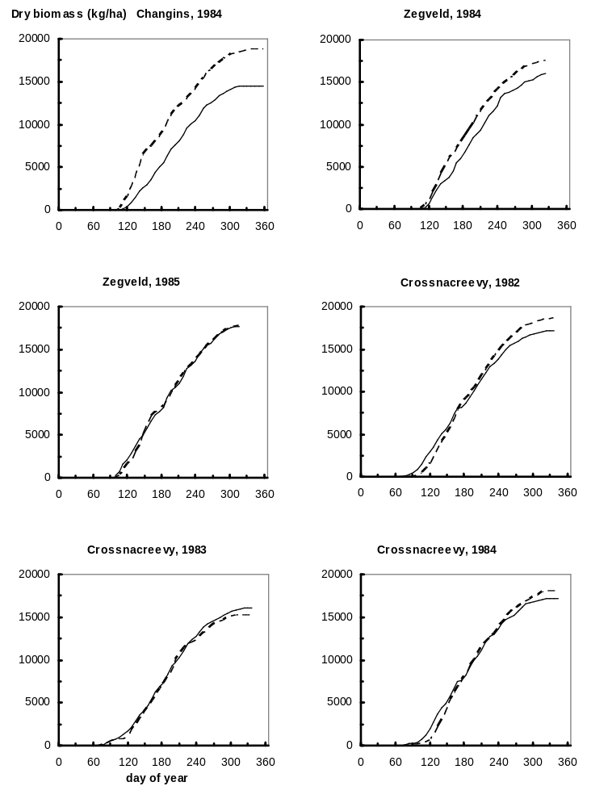
Figure 3.2. Observed (dotted line) and simulated (drawn line) production (harvestable dry matter, kg ha⁻¹) of perennial rye grass at the calibration test sites of the Northern variety. Simulations were performed for the potential production situation.

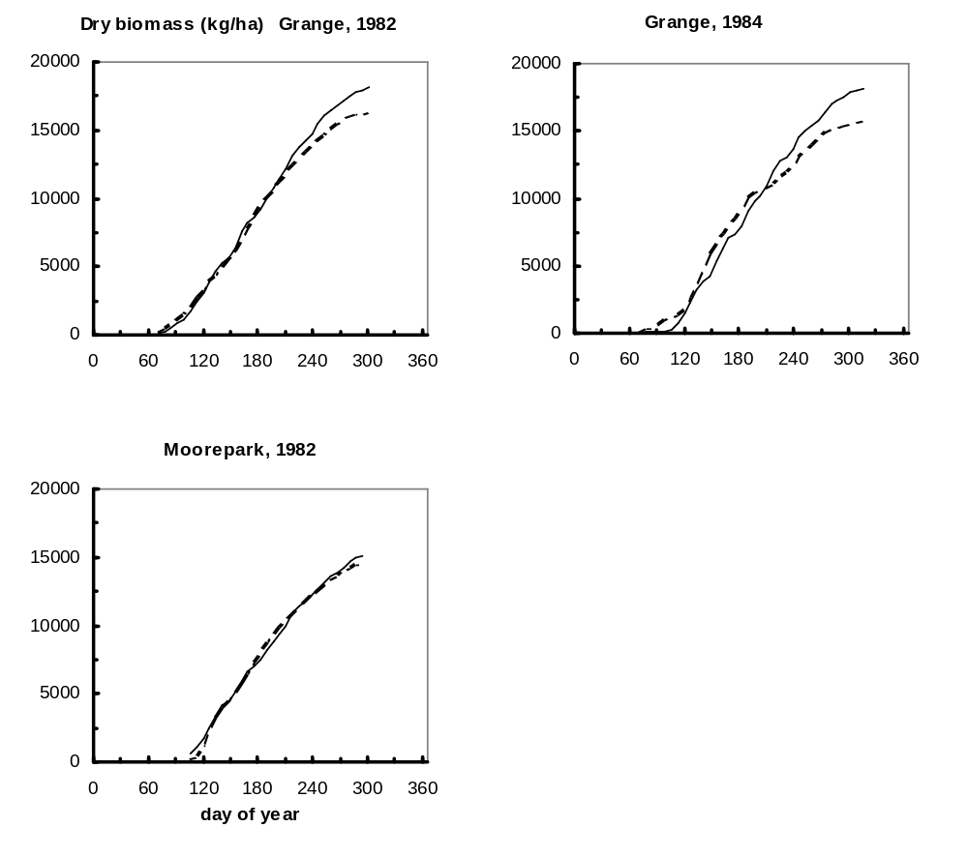
Figure 3.2. Continued. Observed (dotted line) and simulated (drawn line) production (harvestable dry matter, kg ha⁻¹) of perennial rye grass at the calibration test sites of the Northern variety. Simulations were performed for the potential production situation.

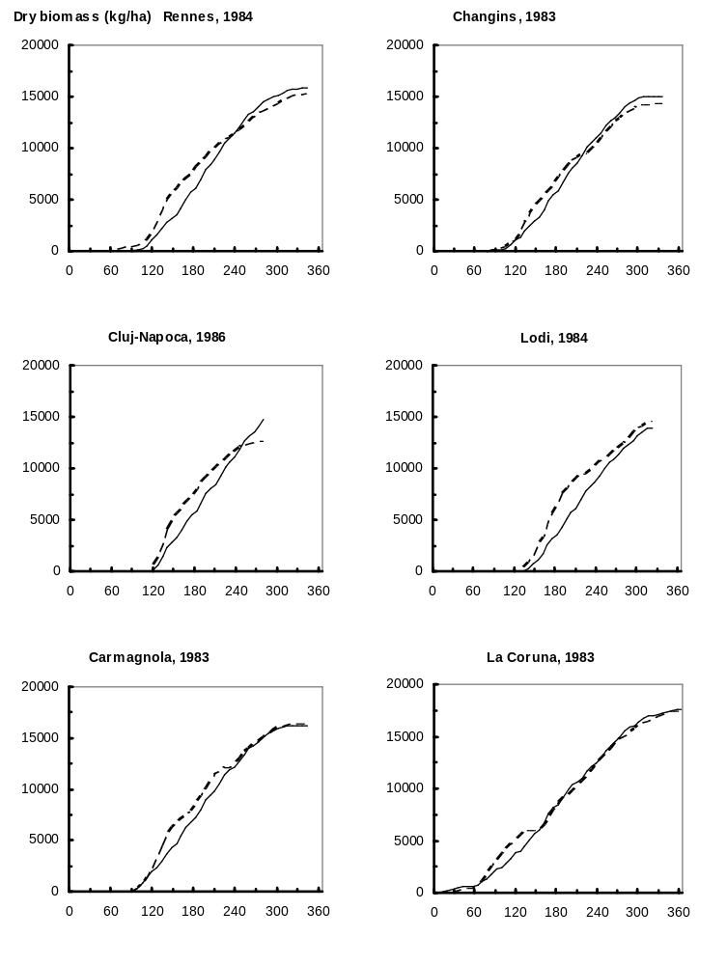
Figure 3.3. Observed (dotted line) and simulated (drawn line) production (harvestable dry matter, kg ha⁻¹) of perennial rye grass at the calibration test sites of the Southern variety. Simulations were performed for the potential production situation.

3.3 Evaluation
The performance of LINGRA was evaluated on independent data sets (i.e. those sets not used for calibration, see Table 3.1) on the level of potential production and water-limited production. For potential production, the water balance model WATPP was used that keeps the soil moisture content at optimum levels for crop growth during the whole growing season. For water-limited production, the water balance model WATFD was used for freely draining soil types. Since no actual soil characteristics for the sites were available, a standard parameter set was used for a medium textured soil type with good water-holding capacity (EC3-medium fine; Hijmans et al., 1994). Also, a standard rooting depth of 40 cm was assumed for all sites. Because of the lack of actual soil and site information, the evaluation of LINGRA at the water-limited level of production should be seen as indicative for trends only, and quite large deviations between simulations and observations can be expected.

Figures 3.4 and 3.5 give the comparison between simulated and observed time courses of grassland biomass at the level of potential production and water-limited production respectively. In general, LINGRA performed very well at the level of potential production, both for Northern and Southern sites. But also at the level of water-limited production, LINGRA performed extremely well in reproducing both trends (pattern of production in time) and absolute production levels throughout Europe. The good performance of LINGRA at the level of water-limited production is quite surprising, considering the lack of soil and site specific input data, and points to a robust behaviour of LINGRA and a high quality of the experimental data.

A quantitative assessment of the performance of LINGRA is given in Table 3.4. In this table, the average absolute error (Eq. 4.1) is given for each experimental data set of the FAO data base (see also Table 3.1).

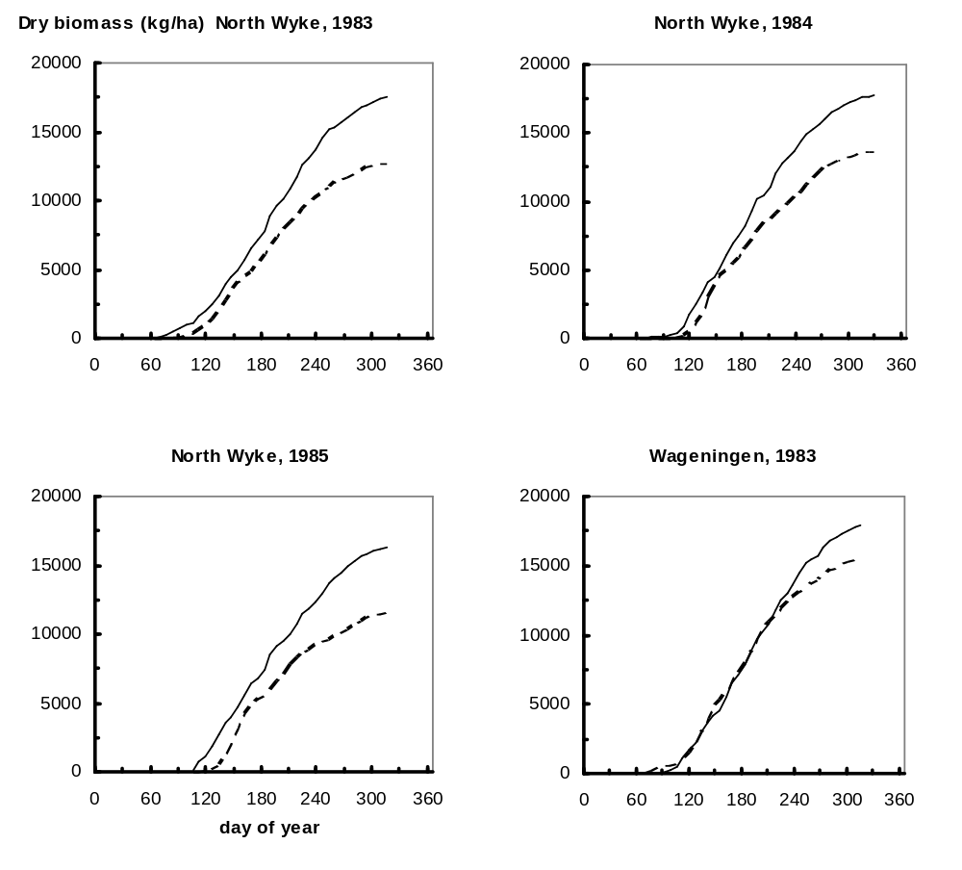
Figure 3.4. Observed (dotted line) and simulated (drawn line) production (harvestable dry matter, kg ha⁻¹) of perennial rye grass at the level of potential production; independent evaluation set.

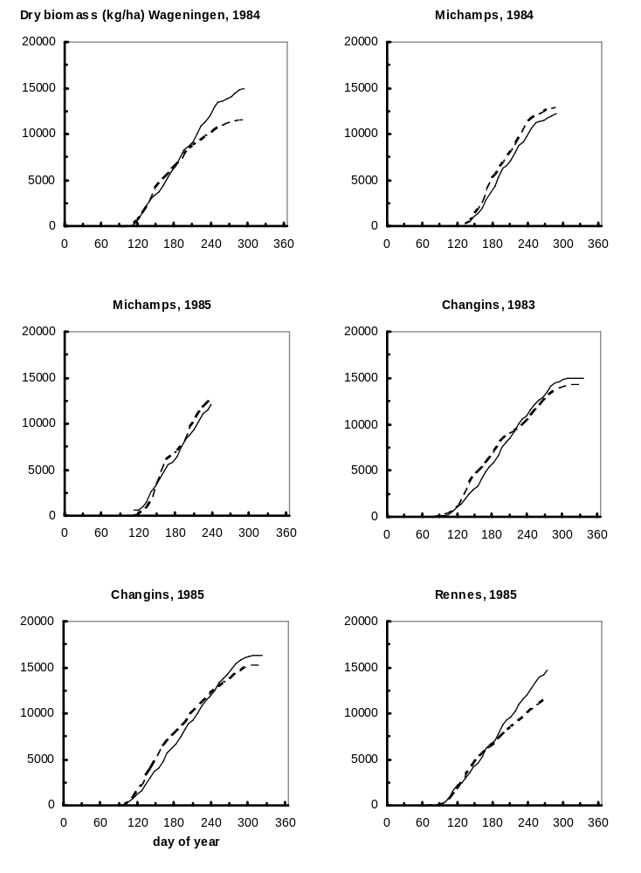
Figure 3.4. Continued. Observed (dotted line) and simulated (drawn line) production (harvestable dry matter, kg ha⁻¹) of perennial rye grass at the level of potential production; independent evaluation set.
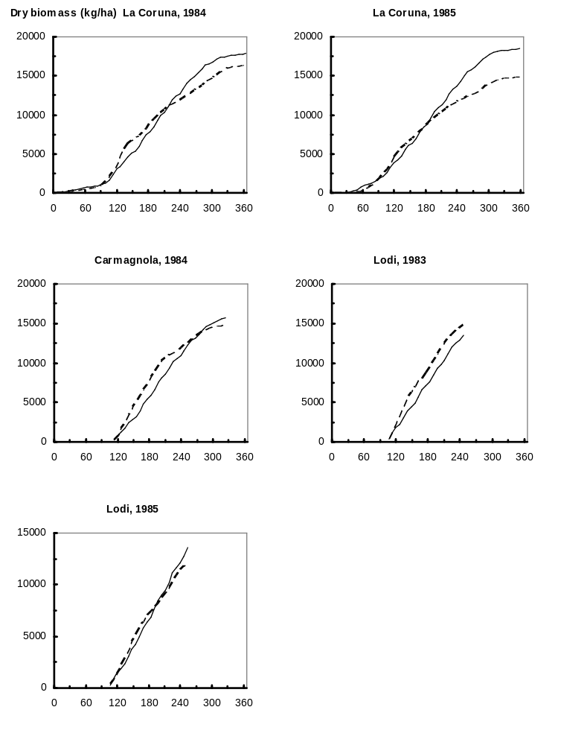
Figure 3.4. Continued. Observed (dotted line) and simulated (drawn line) production (harvestable dry matter, kg ha⁻¹) of perennial rye grass at the level of potential production; independent evaluation set.

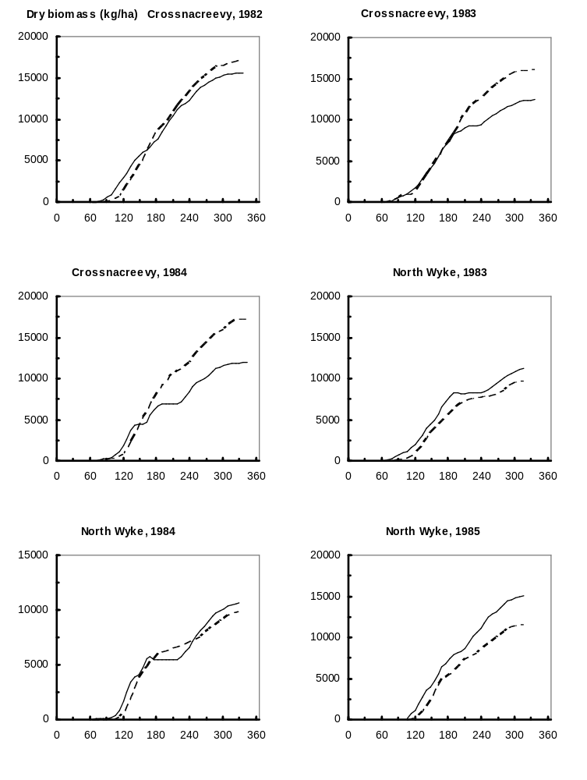
Figure 3.5. Observed (dotted line) and simulated (drawn line) production (harvestable dry matter, kg ha⁻¹) of perennial rye grass at the level of water-limited production; independent evaluation set.
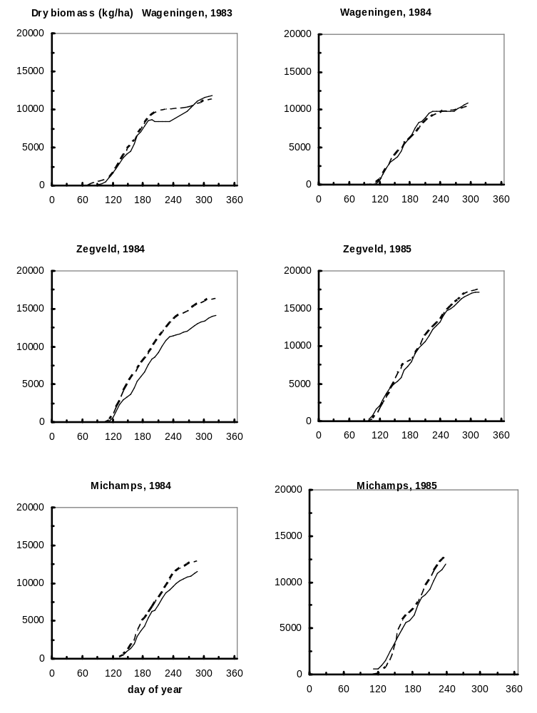
Figure 3.5. Continued. Observed (dotted line) and simulated (drawn line) production (harvestable dry matter, kg ha⁻¹) of perennial rye grass at the level of water-limited production; independent evaluation set.
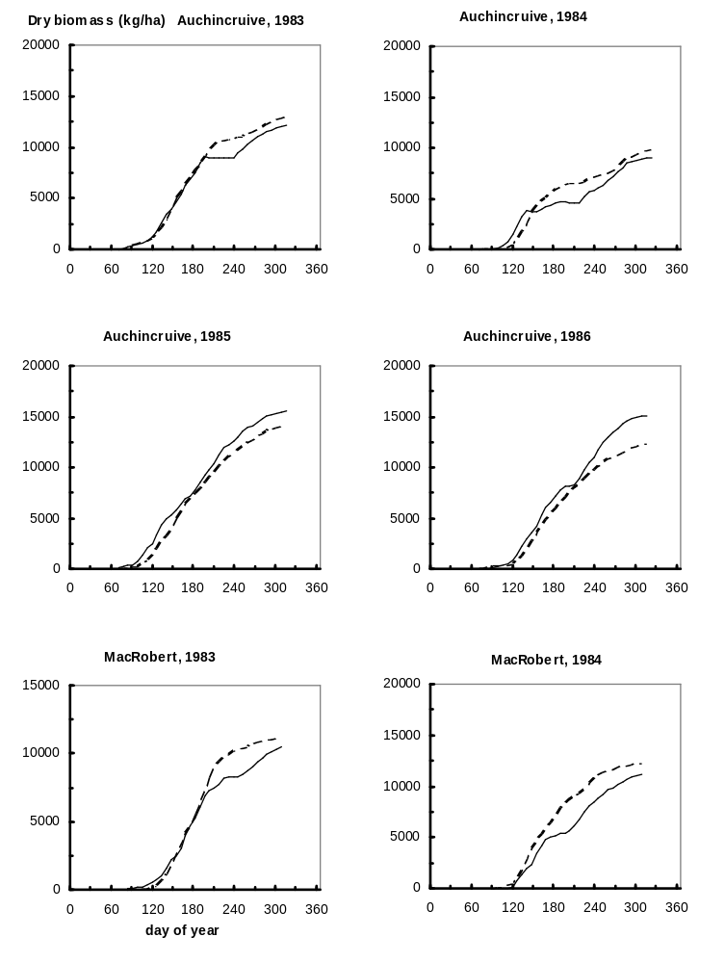
Figure 3.5. Continued. Observed (dotted line) and simulated (drawn line) production (harvestable dry matter, kg ha⁻¹) of perennial rye grass at the level of water-limited production; independent evaluation set.
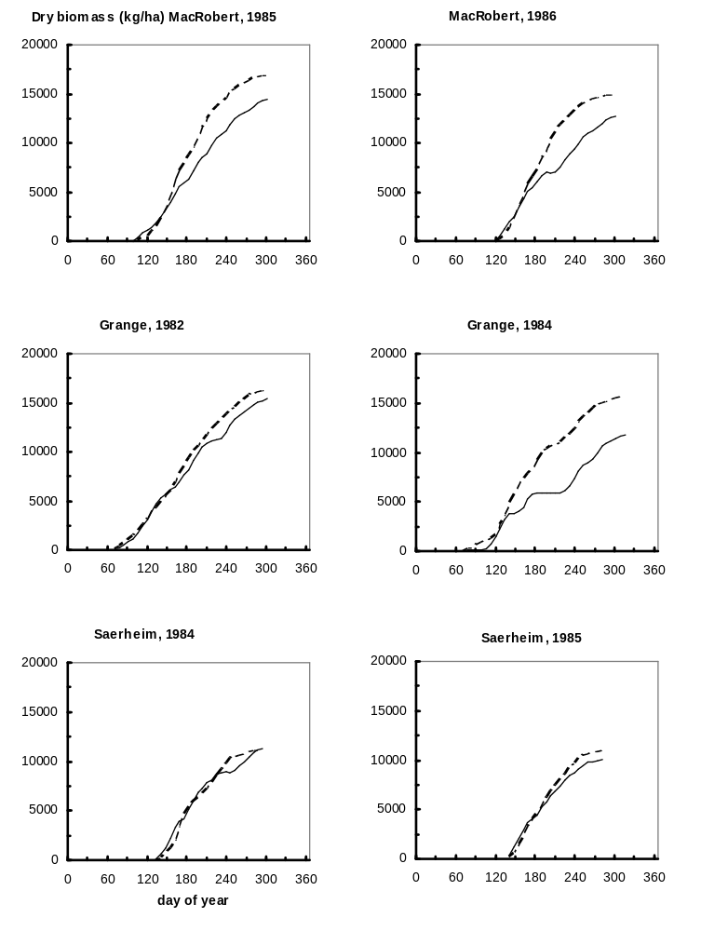
Figure 3.5. Continued. Observed (dotted line) and simulated (drawn line) production (harvestable dry matter, kg ha⁻¹) of perennial rye grass at the level of water-limited production; independent evaluation set.
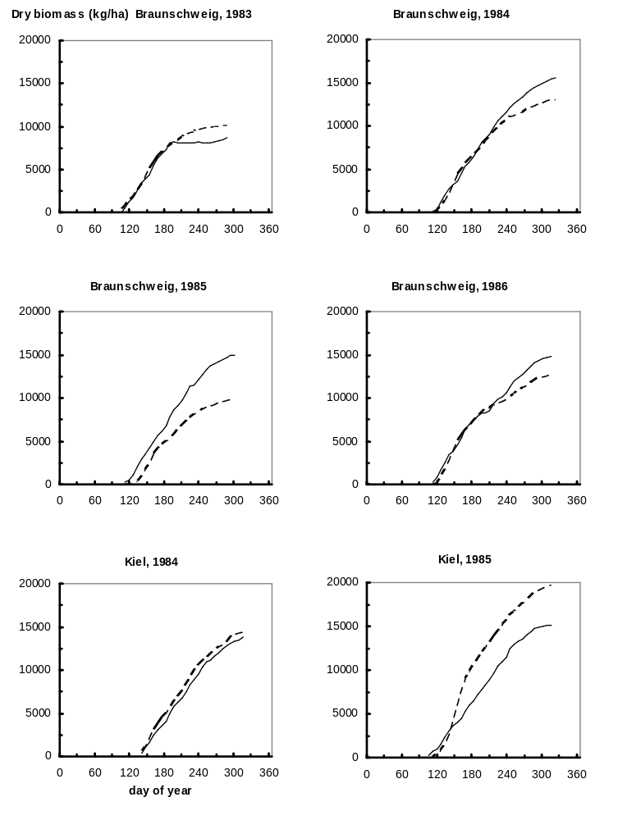
Figure 3.5. Continued. Observed (dotted line) and simulated (drawn line) production (harvestable dry matter, kg ha⁻¹) of perennial rye grass at the level of water-limited production; independent evaluation set.
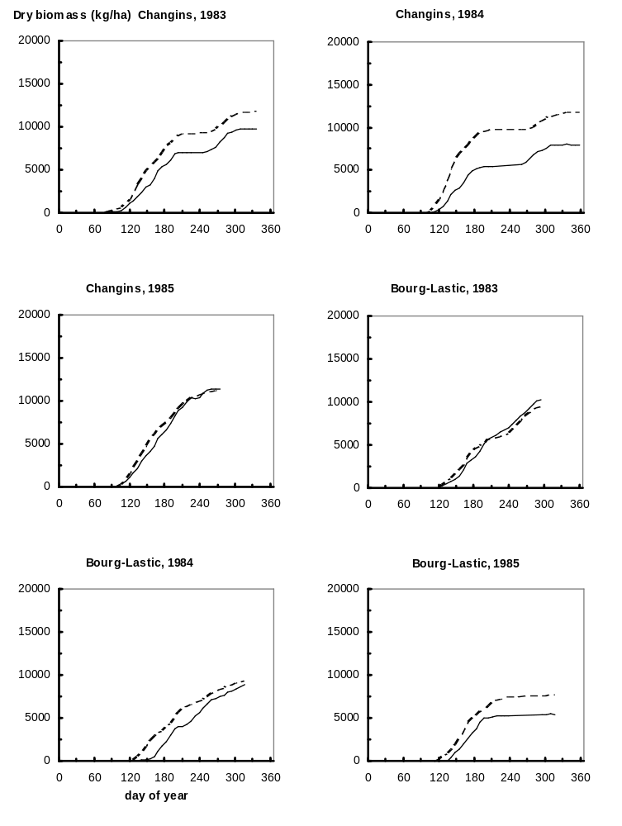
Figure 3.5. Continued. Observed (dotted line) and simulated (drawn line) production (harvestable dry matter, kg ha⁻¹) of perennial rye grass at the level of water-limited production; independent evaluation set.
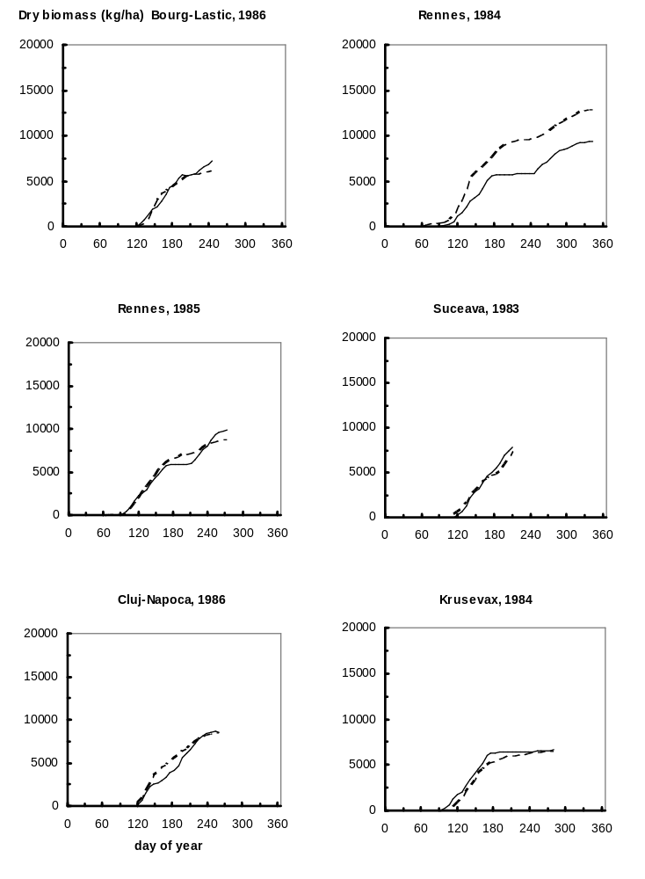
Figure 3.5. Continued. Observed (dotted line) and simulated (drawn line) production (harvestable dry matter, kg ha⁻¹) of perennial rye grass at the level of water-limited production; independent evaluation set.
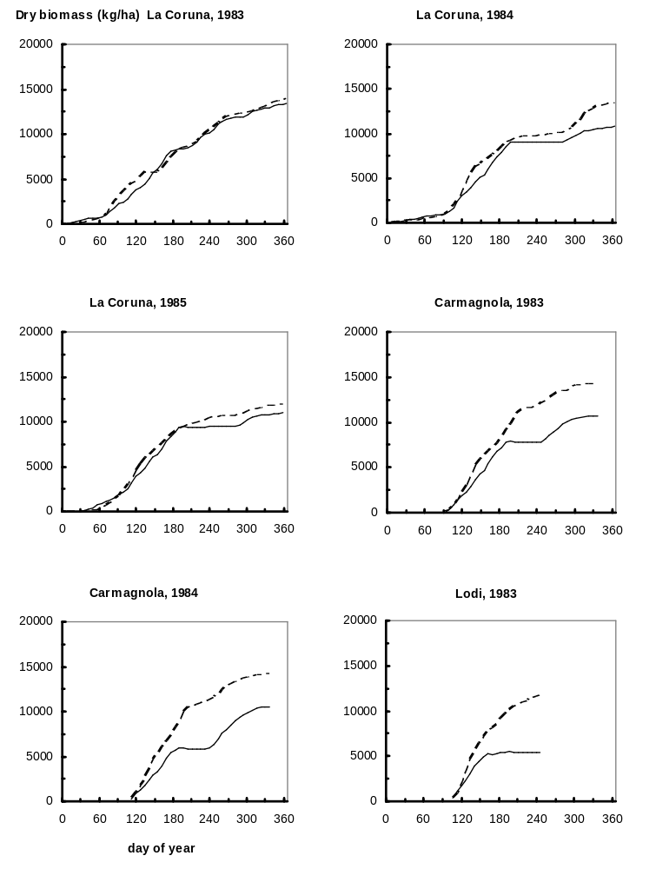
Figure 3.5. Continued. Observed (dotted line) and simulated (drawn line) production (harvestable dry matter, kg ha⁻¹) of perennial rye grass at the level of water-limited production; independent evaluation set.
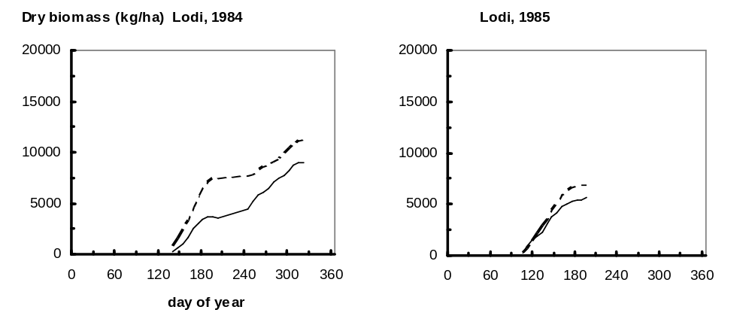
Figure 3.5. Continued. Observed (dotted line) and simulated (drawn line) production (harvestable dry matter, kg ha⁻¹) of perennial rye grass at the level of water-limited production; independent evaluation set.

Table 3.4. Average absolute error (kg dry matter ha⁻¹), calculated as mean absolute difference between weekly simulated and observed harvestable biomass, per experimental data set (see Eq. 4.1)

Country | Experimental site | Year | Avg. absolute  error Irrigated  (kg dm/ha) | Avg. absolute error Non-irrigated  (kg dm/ha) | Data set used for Calibration
Belgium | Michamps | 1984 | 874 | 1090 | -
Belgium | Michamps | 1985 | 644 | 761 | -
Eire | Grange | 1982 | - | 821 | *
Eire | Grange | 1984 | - | 3091 | *
Eire | Moorepark | 1982 | - | 304 | *
England (UK) | North Wyke | 1983 | 2537 | 1031 | -
England (UK) | North Wyke | 1984 | 2178 | 616 | -
England (UK) | North Wyke | 1985 | 2828 | 2125 | -
France | Bourg-Lastic | 1983 | - | 476 | -
France | Bourg-Lastic | 1984 | - | 1266 | -
France | Bourg-Lastic | 1985 | - | 1495 | -
France | Bourg-Lastic | 1986 | - | 365 | -
France | Rennes | 1984 | 990 | 2556 | *
France | Rennes | 1985 | 907 | 482 | -
Germany | Braunschweig | 1983 | - | 800 | -
Germany | Braunschweig | 1984 | - | 1012 | -
Germany | Braunschweig | 1985 | - | 2893 | -
Germany | Braunschweig | 1986 | - | 882 | -
Germany | Kiel | 1984 | - | 741 | -
Germany | Kiel | 1985 | - | 3262 | -
Italy | Carmagnola | 1983 | 690 | 2484 | *
Italy | Carmagnola | 1984 | 1050 | 3452 | -
Italy | Lodi | 1983 | 1508 | 3398 | *
Italy | Lodi | 1984 | 1461 | 2333 | -
Italy | Lodi | 1985 | 559 | 796 | -
N. Ireland (UK) | Crossnacreevy | 1982 | 836 | 950 | *
N. Ireland (UK) | Crossnacreevy | 1983 | 334 | 1726 | *
N. Ireland (UK) | Crossnacreevy | 1984 | 514 | 2726 | *
Netherlands | Wageningen | 1983 | 818 | 556 | -
Netherlands | Wageningen | 1984 | 1139 | 268 | -
Netherlands | Zegveld | 1984 | 1644 | 1892 | *
Netherlands | Zegveld | 1985 | 286 | 461 | *
Norway | Saerheim | 1984 | - | 558 | -
Norway | Saerheim | 1985 | - | 657 | -
Rumania | Cluj-Napoca | 1986 | 1377 | 639 | *
Rumania | Suceava | 1983 | - | 451 | -

Table 3.4. Continued. Average absolute error (kg dry matter ha⁻¹), calculated as mean absolute difference between weekly simulated and observed harvestable biomass, per experimental data set (Eq. 4.1).

Country | Experimental site | Year | Avg. absolute  error Irrigated  (kg dm/ha) | Avg. absolute error Non-irrigated  (kg dm/ha) | Dataset used for Calibration
Scotland (UK) | Auchincruive | 1983 | - | 629 | -
Scotland (UK) | Auchincruive | 1984 | - | 901 | -
Scotland (UK) | Auchincruive | 1985 | - | 991 | -
Scotland (UK) | Auchincruive | 1986 | - | 2539 | -
Scotland (UK) | MacRobert | 1983 | - | 833 | -
Scotland (UK) | MacRobert | 1984 | - | 1496 | -
Scotland (UK) | MacRobert | 1985 | - | 2076 | -
Scotland (UK) | MacRobert | 1986 | - | 2269 | -
Spain | La Coruna | 1983 | 405 | 422 | *
Spain | La Coruna | 1984 | 957 | 965 | -
Spain | La Coruna | 1985 | 1488 | 647 | -
Switzerland | Changins | 1983 | 658 | 1599 | *
Switzerland | Changins | 1984 | 3534 | 3244 | *
Switzerland | Changins | 1985 | 799 | 495 | -
Yugoslavia | Krusevac | 1984 | - | 459 | -

3.4 Overall evaluation and conclusion
Table 3.5 lists average absolute errors (Eq. 4.1) between simulated and observed biomass as mean values over all experiments for the Northern and the Southern areas in Europe. For mutual comparison, these errors were normalized to 50% of the final biomass at the end of the growing season:

Normalized error = 100 {∑(½Y_{t,sim} - Y_{t,obs}½)/n}/Y_{mean, obs} (%) (4.2)

where Y_{t,sim} = simulated biomass at time t; Y_{t,obs} = observed biomass at time t; Y_{mean, obs} = 50% of observed biomass at the end of the growing season; n = number of (weekly) observations.

From Table 3.5, it is seen that the normalized simulation error was about the same for the Northern and Southern sites on the level of potential production. The normalized errors were higher at the level of water-limited production because of the lack of soil and site input data (see Paragraph 3.3). Overall, the values are between 13-21%, which is a very good peformance for crop growth simulation models (Loomis et al., 1979; Penning de Vries, 1983; Bouman et al., 1996).

Figure 3.6 Gives the comparison of simulated total harvested product at the end of the growing season with observed values for the whole data set on the level of potential production (3.6a) and water-limited production (3.6b).

It is concluded that LINGRA performed well in predicting observed grassland production of perennial rye grass experiments throughout Europe, both on the level of potential and water-limited production. Simulated time trends and absolute levels of production matched observed ones well.

Table 3.5. Average absolute error (Eq. 4.1) and normalized absolute error (Eq. 4.2) between LINGRA predictions of harvestable biomass and observed values, as mean values for the Northern and Southern variety areas in Europe. For comparison, the mean of the observed biomass values at the end of the growing season are also given.
 | Region | Potential | Water-limited
Observed biomass values at end of the growing season | Northern | 16668 | 15230
(kg dry matter ha⁻¹) | Southern | 17494 | 13422
Average absolute error (kg dry matter ha⁻¹) | Northern | 1215 | 1327
 | Southern | 1156 | 1410
Normalized average error (%) | Northern | 14.6 | 17.4
 | Southern | 13.2 | 21.0

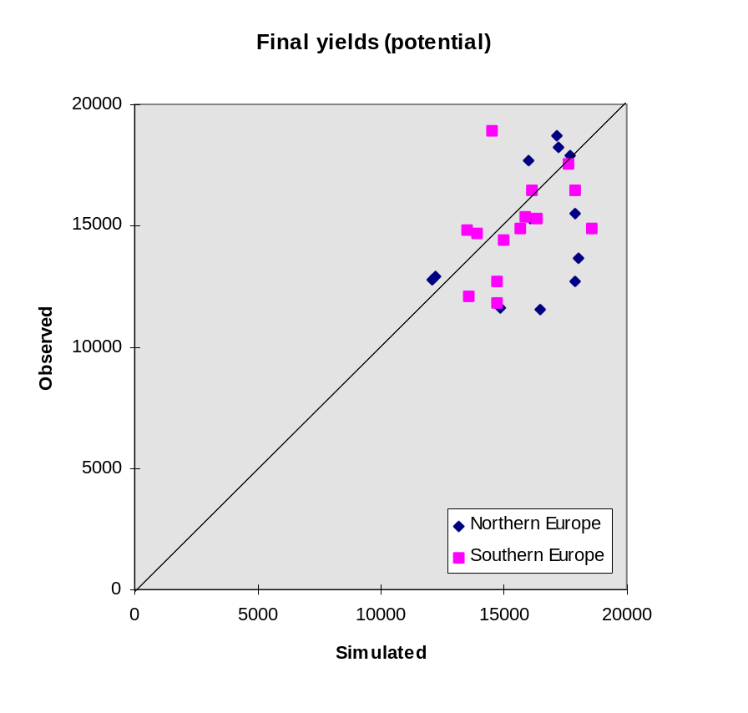

Figure 3.6a. Observed against simulated values of total harvested product at the end of the growing season on the level of potential production. Diamonds indicate the Northern European sites; squares the Southern European sites.

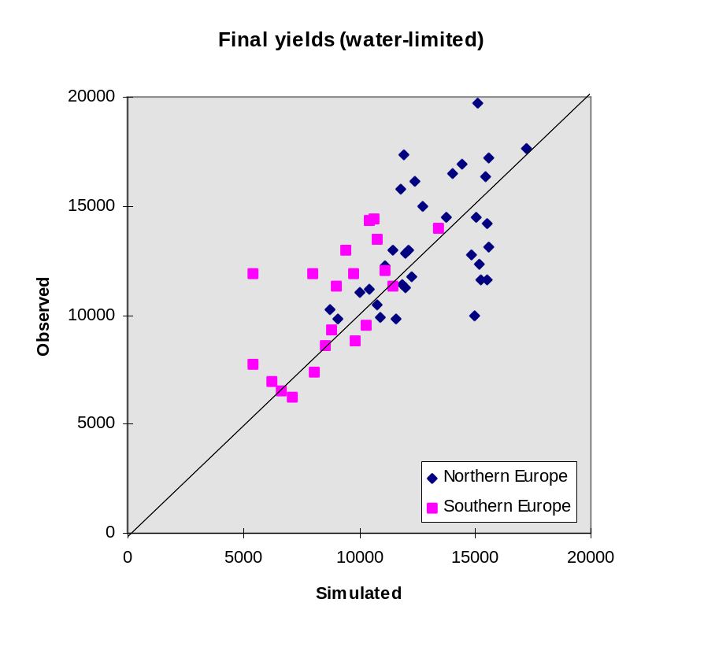

Figure 3.6b. Observed against simulated values of total harvested product at the end of the growing season on the level of water-limited production. Diamonds indicate the Northern European sites; squares the Southern European sites.

References
Beek., E.G., 1991. Spatial interpolation of daily meteorological data. using kriging to predict daily rainfall in north-western Europe. SC-DLO report 53.2. SC-DLO, Wageningen, The Netherlands. 117 pp.

Biscoe, P.V. & J.N. Gallagher, 1977. Weather, dry matter production and yield. In: J.J. Landsberg & C.V. Cutting (Eds.): Environmental effects on crop physiology. Academic Press, London:75-100.

Boons-Prins, E.R., G.H.J. de Koning, C.A. van Diepen & F.W.T. Penning de Vries, 1994. Crop specific simulation parameters for yield forecasting across the European Community. Simulation Reports CABO-TT 32. AB-DLO, Wageningen, The Netherlands. 43 pp. + appendices.

Bouman, B.A.M., H. van Keulen & H.H. van Laar, 1996 The 'School of de Wit' crop growth simulation models: pedigree and historical overview. In press by Agricultural Systems (December 1995)

Burril, A., P. Vossen & C.A. van Diepen, 1995. A GIS database for crop modelling. In: D. King, R.J.A. Jones, A.J. Thomasson (Eds.). European land information systems for agro-environmental monitoring. EUR publication 16232 EN of the Office for Official Publications of the EC; series ‘Agriculture’. Luxembourg. pp. 143-154.

Corrall, A.J. & J.S. Fenlon, 1978. A comparative method for describing the seasonal distribution of production from grasses. Journal of Agricultural Science, Cambridge, 91, 61-67

Corrall, A.J., R.H. Lavender, & Cora P. Terry, 1979. Grass species and varieties: seasonal patterns of production and relationships between yield, quality and date of first harvest. Grassland Research Institute Technical Report No. 26, Hurley, UK, 23 pp.

Corrall, A.J., 1984. Grass growth and seasonal pattern of production under varying climatic conditions. In: Riley, H. and A.O. Skjelvåg (Eds.), The impact of climate on grass production and quality. Proceedings of the 10th meeting of the European Grassland Federation, 26-30 June 1984, Ås, Norway

Corrall, A.J., 1988. Prediction of production from grassland. Information Bulletin of the FAO European Research Co-operative Network on Pastures and Field Crops (Herba), no. 1. Published by the Agronomy Institute of the University of Florence, Italy. pp. 25-28.

Davies, A. & Thomas, H., 1983. Rates of leaf and tiller production in young spaced perennial ryegrass plants in relation to soil temperature and solar radiation. Ann. Bot. 57, 591-597.

De Koning, G. H. J., M. J. W. Jansen, E. R. Boons-Prins, C.A. Van Diepen & F.W.T. Penning de Vries, 1993. Crop growth simulation and statistical validation for regional yield forecasting across the European Community. Simulation Reports CABO-TT, no. 31. CABO-DLO, Wageningen. 105 pp.

De Wit, C.T. & F.W.T. Penning de Vries, 1982. L'Analyse des systèmes de production primaire. In: La productivité des pâturages sahéliens. Une étude des sols, des végétations et de l'exploitation de cette ressource naturelle, eds. F.W.T. Penning de Vries & M.A. Djitèye, Agricultural Research Reports 918, PUDOC, Wageningen, The Netherlands, pp. 20-27.

Gaastra, P., 1958. Light energy conversion in field crops in comparison with the photosynthetic efficiency under laboratory conditions. Meded. Landb.Hogesch. Wageningen, 58(4):1-12.

Genovese, G., 1994. Progetto MARS: la valutazione degli scenari agricoli. PROTECTA, Anno VIII, Sedifim, Roma, Italy, Volume 3: 34-37.

Gommes, R., 1995. Crop yield forecasting for food security monitoring and warning. Pages 37-42 in Pre-proceedings Seminar 'Yield Forecasting', 24-27 October 1995, Villefranche-sur-Mer, France.

Gosse, G., C. Varlet-Grancher, R. Bonhomme, M. Chartier, J.-M. Allirand & G. Lemaire, 1986. Production maximale de matière sèche et rayonnement solaire intercepté par un couvert végétal. Agronomie 6: 47-56.

Heath, D.W., 1990. Introductory remarks. In: Proceedings of the Conference on The Application of Remote Sensing to Agricultural Statistics (Edited by F. Toselli and J. Meyer-Roux), 10-11 october 1989, Varese, Italy (Publisher: Commission of the European Communities). pp. 19-23.

Hijmans, R.J., I.M. Guiking-Lens & C.A. van Diepen, 1994. WOFOST 6.0, User’s guide for the WOFOST 6.0 crop growth simulation model. Technical Document 12, SC-DLO, Wageningen, The Netherlands. 145 pp.

King, D., D. Daroussin & M. Jamagne, 1994. Development of a soil geographic database from the soil map of the European Communities. Catena, 21: 37-56.

Klepper, O. & D.I. Rouse, 1991. A procedure to reduce parameter uncertainty for complex models by comparison with real system output illustrated on a potato growth model, Agricultural Systems 36:375-395

Kooman, P.L., 1995. Yielding ability of potato crops as influenced by temperature and daylength. Ph.D. Thesis, Wageningen Agricultural University, Wageningen. 155 pp.

Kuipers, N., 1995. Crop estimates in The Netherlands. Pages 311-312 in Pre-proceedings Seminar 'Yield Forecasting', 24-27 October 1995, Villefranche-sur-Mer, France.

Le Bas, C., D. King, M. Jamagne, J. Daroussin & P. Vossen, 1994. Une base géographique de données de sols pour la gestion de l’agriculture et de l’environnement en Europe. Paper presented at the EGIS MARI’94 Conference, Paris. pp. 1548-1577.

Loomis, R.S., R. Rabbinge & E. Ng, 1979. Explanatory models in crop physiology. Ann. Rev. Pl. Phys. 30:339-367.

Meteoconsult, 1991.AMDaC user manual. Software package for actual meteorological databse construction. Wageningen, The Netherlands. 60 pp. + appendices.

Meyer-Roux, J. & P. Vossen, 1994. The first phase of the MARS project, 1988-1993: overview, methods and results. Pages 33-85 in Proceedings of the Conference on the MARS project: overview and perspectives. Commission of the European Communities, Luxembourg.

Monteith, J.L., 1977. Climate and the efficiency of crop production in Britain. Phil. Trans. Royal Soc. London, Series B, 281:277-294.

Palm, R. & P. Dagnelie, 1993. Tendance et effets du climat dans la prevision des rendements agricoles des differents pays de la C.E. Joint Research Centre of the EC Publication EUR 15106 F of the Office for Official Publications of the EC. Luxembourg, Ispra, 128 pp.

Penning de Vries, F.W.T., 1983. Modeling of growth and production. Encyclopedia of Plant Physiology, New Series 12D. Springer Verlag, Berlin. pp:117- 150.

Penning de Vries, F.W.T. & H.H. van Laar (Eds.), 1982. Simulation of plant growth and crop production. Simulation Monographs, Pudoc, Wageningen: 307 pp.

Penning de Vries, F.W.T., D.M. Jansen, H.F.M. ten Berge & A. Bakema, 1989. Simulation of ecophysiological processes of growth in several annual crops. Simulation Monographs 29, Pudoc, Wageningen: 271 pp.

Price, W. L., 1979. A controlled random search procedure for global optimization, The Computer Journal 20:367-370

Rappoldt, C. & D.W.G. van Kraalingen, 1990. Reference manual of the FORTRAN utility library TTUTIL with applications. Simulation report CABO-TT no. 20, CABO, Wageningen, The Netherlands. 122 pp.

Schapendonk, A.H.C.M. & A.L.F. de Vos, 1988. Implications of selecting for persistency in timothy (Phleum pratense L.). Euphytica Science: 131-139.

Spitters, C.J.T., 1987. An analysis of variation in yield among potato cultivars in terms of light absorption, light utilisation and dry matter partitioning. Acta Horticulturae 214: 71-84.

Spitters, C.J.T., 1988. Modelling crop growth and tuber yield in Helianthus tuberosus. Proceedings Jerusalem artichoke EEC Workshop 1987, Madrid. Commission of the European Communities, Luxembourg, Report EUR 11855: pp. 29-35.

Spitters, C.J.T., 1990. Crop growth models: their usefulness and limitations. Acta Horticulturae 267: 345-363

Spitters, C.J.T. & A.H.C.M. Schapendonk, 1990. Evaluation of breeding strategies for drought tolerance in potato by means of crop growth simulation. Plant and Soil 123, 193-203.

Spitters, C.J.T. & A.H.C.M. Schapendonk, 1989. Evaluation of breeding stategies for drought tolerance in potato by means of crop growth simulation. Proceedings 3rd International Symposium on 'Genetic aspects of plant mineral nutrition', Braunschweig, June 1988. Kluwer, Dordrecht, the Netherlands, in press.

Spitters, C.J.T., H. Van Keulen & D.W.G. Van Kraalingen, 1989. A simple and universal crop growth simulator: SUCROS87. In: R. Rabbinge, S.A. Ward & H.H. Van Laar (Eds.), Simulation and systems management in crop protection. Simulation Monographs 32, Pudoc, Wageningen: 147-181.

Stadler, R., 1995. Harvest preview and yield forecasts in Baden Württemberg. Pages 299-310 in Pre-proceedings Seminar 'Yield Forecasting', 24-27 October 1995, Villefranche-sur-Mer, France.

Stol, W., D.I. Rouse, D.W.G. Van Kraalingen & O. Klepper, 1992. FSEOPT, a FORTRAN program for calibration and uncertainty analysis of simulation models. Simulation report CABO-TT, 24. CABO-DLO, Wageningen, The Netherlands. 23 pp. + appendices.

Supit, I., A.A. Hooijer & C.A. Van Diepen (Eds.), 1994. System description of the WOFOST 6.0 crop growth simulation model implemented in CGMS. Joint Research Centre, Commission of the European Communities, Brussels, Luxemburg. 144 pp.

Van der Drift, J.W.M. & C.A. Van Diepen, 1992. The DBMETEO data base on the countries of the European Communities. Description of the data and data-treatment. Technical document 4, SC-DLO, Wageningen, The Netherlands. 75 pp.

Van Diepen, C. A., J. Wolf, H. Van Keulen & C. Rappoldt, 1989. WOFOST: a simulation model of crop production. Soil Use and Management 5: 16-24.

Van Keulen, H., 1975. Simulation of water use and herbage growth in arid regions. Simulation Monographs, PUDOC, Wageningen, The Netherlands. 176 pp.

Van Keulen, H., & J. Wolf (Eds), 1986. Modelling of agricultural production: weather, soils and crops, Simulation Monographs, PUDOC, Wageningen, The Netherlands. 479 pp.

Van Kraalingen, D.W.G., 1995. The FSE system for crop simulation, version 2.1. Quantitative Approaches in Systems Analysis, 1. AB-DLO, Wageningen, The Netherlands. 58 pp.

Van Kraalingen, D.W.G, W. Stol, P.W.J. Uithol & M.G.M. Verbeek, 1990. User manual of CABO/TPE Weather System. CABO/TPE Internal communication, CABO, Wageningen, The Netherlands. 27 pp.

Van Loo, E.N., 1993. On the relation between tillering, leaf area dynamics and growth of perennial ryegrass (Lolium perenne L.) PhD thesis, Department of Agronomy, Agricultural University, Wageningen.

Van Raaij, B.F.T. & T. Van der wal., 1994. CGMS 3.1, Technical Description. Technical Document 15.3, SC-DLO, Wageningen, The Netherlands. 205 pp.

Vossen, P., 1990. Modèles agrométéorologiques pour le suivi de cultures et de la prévision des rendements des grandes régions de Communautés Européennes. In: Proceedings of the Conference on The Application of Remote Sensing to Agricultural Statistics (Edited by F. Toselli and J. Meyer-Roux), 10-11 october 1989, Varese, Italy (Publisher: Commission of the European Communities). pp. 75-84.

Vossen, P., 1992. Forecasting national crop yields of EC countries: the approach developed by the Agriculture Project: Pages 159-176 in Proceedings of the Second Conference on The Application of Remote Sensing to Agricultural Statistics, Belgirate, Italy. Publication EUR 14262 EN of the Office for Official Publications of the EC, Luxembourg.

Vossen, P., 1995. Early assessment of national crop yields: the approach developed by the MARS-STAT Project on behalf of the European Commission. Pages 323-347 in Pre-proceedings Seminar 'Yield Forecasting', 24-27 October 1995, Villefranche-sur-Mer, France.

Vossen, P. & D. Rijks, 1995. Early crop yield assessment of the EU countries: the system implemented by the Joint Research Centre. Publication EUR 16318 of the Office for Official Publications of the EC, Luxembourg. 180 pp.

Whisler, F.D., B. Acock, D.N. Baker, R.E. Fye, H.F. Hodges, J.R. Lambert, H.E. Lemmon, J.M. McKinion & V.R. Reddy, 1986. Crop simulation models in agronomic systems. Advances in Agronomy 40:141-208.

Wisiol, K. & J.D. Hesketh, 1987. Plant growth modeling for resource management. CRC Press, Boca Raton, Florida, Vol. 1:170 pp., Vol.2:178 pp.

Appendix I: variable name listing
Name | Explanation | Units
A | Factor in calculation of soil water depletion factor | -
B | Factor in calculation of soil water depletion factor | -
CFET | Correction factor for transpiration rate | -
CGNR | Crop group number | -
CINT | Cumulative daily amount of absorbed PAR | MJ.ha-1
CLAI | Remaining leaf area index after cutting | ha leaf ha ground-1
COCON | Atmospheric CO2 concentration | ppm
CRAIRC | Critical air content in the root zone | (cm3 cm-3)
CTRA | Cumulative transpiration | cm
CWGHT | Criterium for mowing when MOPT equals 1 | kg ha-1
CWLVG | Remaining leaf weight after cutting | kg ha-1
DAHA | Number of days after latest cutting | d
DD | Effective depth of drains (drainage base) | cm
DELT | Time interval of integration | d
DEPNR | Crop group number for soil water depletion | -
DLAI | Death rate of leaf area | ha.ha-1.d-1
DLAIS | Rate of sink limited leaf growth | tillers m-2
DLV | Death rate of leaf biomass | kg leaf.ha-1.d-1
DRE | Rate of decrease of short lived carbohydrate pool | kg CH2O.ha-1.d
DSOS | Number of days since start of oxygen shortage | d
DT | Estimated temperature difference between surface height and reference height | degrees C
DTIL | Rate of tiller formation | tillers m-2 d-1
DTILD | Relative death rate of tillers due to self-shading | tiller tiller-1 d-1
DVS | Development stage of the crop | -
E0 | Potential evapotranspiration | cm d-1
EKL | Intermediate variable in calculation of evaporation | mm d-1
ELEV | Elevation of site | m
ES0 | Potential soil evaporation | cm d-1
ET0 | Potential transpiration | cm d-1
ETAE | Dryness driven part of potential evapotranspiration | mm.d-1
ETC | Crop specific correction on potential transpiration rate | cm d-1
ETD | Potential evapotranspiration | mm.d-1
ETMOD | Name of evapotranspiration module used in simulation | -
ETRD | Radiation driven part of potential evapotranspiration | mm.d-1
EVSMX | Maximum evaporation rate from soil surface | cm d-1
EVWMX | Maximum evaporation rate from water surface | cm d-1
FILEI1 | Name of input file no. 1 | -
FILEI2 | Name of input file no. 2 | -
FILEI3 | Name of input file no. 3 | -
FILEIN | File name with which model parameters are read | -
FILEIT | Name of timer file | -
FINT | Fraction interception | -
FLV | Fraction of shoot dry matter allocated to leaves | -
FRRO | Partitioning of dry matter to roots as affected by drought | -
FRT | Fraction of total dry matter allocated to roots | -
FSMAX | Maximum site filling new buds | -
GIVEN | Flag whether message is already given | -
GLAI | Rate of increase of green leaf area | ha leaf.ha-1 ground.d-1
GLV | Dry matter growth rate of leaves | kg dm.ha-1 ground.d-1
GRASS | Dry weight of cutted green leaves | kg ha-1
GRE | Reserve pool growth rate | kg CH2O.ha-1 ground.d-1
GRT | Dry matter growth rate of roots | kg DM.ha-1 ground.d-1
GTW | Gross growth rate of crop dry matter, including translocation | kg DM.ha-1 ground.d-1
GTWMTH | Four-weekly moving average of total growth rate | kg ha-1 d-1
GTWSI | Total sink limited carbon demand | kg leaf ha ground-1 d-1
GTWSO | Source limited growth rate of crop | kg ha-1 d-1
HARV | Daily harvest rate of dry matter | kg ha-1 d-1
I1 | DO-loop counter
IAIRDU | Air ducts in roots present (=1) or not (=0) | -
IDEM | Day of emergence | d
IDHALT | Last day of simulation | d
IDOY | Day number within year of simulation | d
IDRAIN | Presence of drains | -
IFUNRN | Indicates whether non-infiltrating fraction of rain is a function of storm-size | -
ILAI | Initial leaf area index | ha leaf ha ground-1
ILFRRO | Actual number of values in array FRRO | -
ILLUE1 | Actual number of values in array LUERED1 | -
ILLUE2 | Actual number of values in array LUERED2 | -
ILOBSD | Actual number of values in array | -
IMFRRO | Maximum number of values in array FRRO | -
IMLUE | Maximum number of values in array LUERED1 | -
IMNDAT | Maximum number of values in array IMNDAT | -
IMOBSD | Maximum number of values in array IMOBSD | -
IMOPT | Variable that defines crop management | -
INCUT | Number of cuttings | -
INTIL | Initial number of tillers | tillers m-2
IOX | Variable that defines oxygen shortage (=1)or not (=0) | -
ISTO | Initial weight of reserves | kg ha-1
ITASK | Task that subroutine should perform | -
IUNITD | Unit number that is used for input files | -
IUNITL | Unit number that is used for log file | -
IUNITO | Unit number that is used for output file | -
IWB | Variable that defines type of waterbalance (WATPP=0, WATFD=1) | -
IWLVG | Initial leaf weight | kg ha-1
IWVAR | Counter variable in control of weather data | -
IYEAR | Year of simulation | y
KDF | Extinction coefficient of leaves for PAR and for diffuse light | ha ground.ha-1 leaf
KDIF | Extinction coefficient of leaves for PAR and for diffuse light | ha ground.ha-1 leaf
KGLOB | Extinction coefficient for total global radiation | ha ground.ha-1 leaf
LAI | Green leaf area index | m2 leaf.m-2 ground
LAICR | Critical leaf area index beyond which death to self-shading occurs | ha leaf.ha-1 ground
LAT | Latitude of site | dec.degr.
LEAFN | Temperature dependent leaf appearance rate | leaves tiller-1 day-1
LENGTH | Length of leaves | cm
LERA | Leaf elongation rate affected by temperature | cm day-1 tiller-1
LERA2 | Effective leaf elongation rate affected by temperature and cutting | cm day-1 tiller-1
LUE | Light use efficiency | g MJ PAR-1
LUED | Actual light use efficiency | g dm MJ PAR-1
LUEMAX | Maximum light use efficiency | g MJ PAR-1
LUERED1 | Reduction function on light use efficiency | -
LUERED2 | Reduction function on light use efficiency | -
MOWDAY | Boolean variabel indicating periodical harvest | -
NITMAX | Maximum nitrogen content of leaves | kg kg-1
NITR | Actual nitrogen content of leaves | kg kg-1
NOTINF | Maximum fraction of rain not-infiltrating into the soil | -
NOTNUL | Real function to overcome zero-division | -
OUTPUT | Flag to indicate if output should be done | -
OXMOD | Choice of water-balance | -
PAR | Daily photosynthetically active radiation | MJ m-2 d-1
PARINT | Total intercepted photosynthetically active radiation | MJ m-2 d-1
RAIN | Daily amount of rainfall | mm.d-1
RAINW | Precipitation in centimeters per day | cm d-1
RD | Depth of actual root zone | cm
RDAHA | Rate of days after harvest | -
RDCROP | Rooting depth of the crop | cm
RDD | Daily shortwave radiation | J.m-2.d
RDI | Initial rooting depth | cm
RDM | Maximum rooting depth | cm
RDMCR | Crop-dependent maximum rooting depth | cm
RDMSOL | Maximum rooting depth of the soil | cm
RDR | Relative death rate of leaves | d-1
RDRD | Base relative death rate of leaves | d-1
RDRS | Maximum of relative death rate of leaves due to and drought stres | d-1
RDRSH | Relative death rate due to self-shading at high LAI | d-1
RDRSM | Relative death rate of leaves due to drought stress | d-1
RDUM1 | Dummy variable in calculation | -
RDUM2 | Dummy variable in calculation | -
RED | Temperature reduction factor on light use efficiency | -
REDRDD | Reduction factor on light use efficiency on basis of radiation intensity | -
REFTIL | Relative rate of tiller formation | tiller tiller-1 d-1
RF | Reflection (=albedo) of surface | -
RFOS | Reduction factor due too oxygen stress | -
RFOSMX | Maximum reduction due too oxygen stress | -
RFS | Reflection coefficient of soil | -
RFWS | Reduction in transpiration in case of water shortage | -
SLA | Specific leaf area | ha leaf.kg-1 leaf
SLAINT | Value of specific leaf area in model | ha kg-1
SM | Soil moisture content in the rooted zone | (cm3 cm-3)
SM0 | Soil porosity, saturated moisture content | (cm3 cm-3)
SMAIR | Soil moisture content at airdry | (cm3 cm-3)
SMCR | Critical soil moisture content | (cm3 cm-3)
SMFCF | Soil moisture content at field capacity | (cm3 cm-3)
SMW | Soil moisture content at wilting point | (cm3 cm-3)
SOILTMP | Soil temperature | gr. C.
SSI | Initial surface storage | cm
SSMAX | Maximum surface storage | cm
SWDEP | Soil water depletion factor | -
SWEAF | Fraction of easily available soil water | -
TADRW | Total above-ground dry matter | kg DM.ha-1
TERMNL | Flag to indicate if simulation is to stop | -
TILLER | Number of tillers | tillers m-2
TMBASE1 | Daily average temperature (10-day moving average) at which onset of crop growth is defined | gr. C.
TMBASE2 | Daily average temperature (10-day moving average) above which temperature does not reduce dry matter accumulation | gr. C.
TMDA | Daily average temperature | degrees C
TMEFF | Effective increase in overall temperature sum | degrees C
TMMN | Daily minimum temperature | degrees C
TMMX | Daily maximum temperature | degrees C
TMPR1 | Temporary real variable
TRA | Transpiration rate | cm d-1
TRAMX | Maximum crop transpiration rate | cm d-1
TRAMXT | Cumulative potential transpiration | cm d-1
TRANRF | Transpiration reduction factor | cm d-1
TREATMENT | Name of treatment that is simulated | -
TSUM | Sum of temperatures above base temperature | øC d
VP | Early morning vapour pressure | kPa
WATMOD | Name of water balance module used in simulation | -
WAV | Initial (at emergence) amount of water in excess of wilting point, but not exceeding field capacity | cm
WLVD | Dry weight of dead leaves | kg.ha-1
WLVG | Dry weight of green leaves | kg.ha-1
WN | Average wind speed | m.s-1
WRE | Weight of carbyhydrate reserves | kg CH2O.ha-1
WRT | Dry weight of the roots | kg.ha-1
WSTAT | Status code from weather system | -
WTRTER | Flag whether weather can be used by model | -
WUSED | String indicating which weather variables are used by the model | -
YIELD | Harvestable part of total above ground dry weight and previous harvests | kg ha-1
ZT | Actual depth of groundwater table | cm
ZTI | Initial depth of groundwater table | cm

Appendix II: model input file
The input file that contains LINGRA crop parameter values is given here. Soil, site and weather input data are the same as stored in CGMS for the WOFOST model (namely to run the evapotranspiration routines and the water balances; see Hijmans et al., 1994).

* CROP DATA INPUT FILE LINGRA
* model parameters resulting from calibration at
* 'potential' experiments in western-europe
TMBASE1 = 3. ; TMBASE2 = 8. ; CLAI = 0.8 ; LUEMAX = 3.

* model parameters resulting from calibration at
* 'potential' experiments under mediterranean conditions
* TMBASE1 = 5. ; TMBASE2 = 9.7 ; CLAI = 0.5 ; LUEMAX = 2.44

TREATMENT = 'Run with default parameters'

* Crop management parameters
* --------------------------
* Mowing option parameter;
* 1 = mowing when TADRW at criterium CWGHT
* 2 = mowing at dates of periodical harvests
IMOPT = 2

* Criterium for mowing when MOPT equals 1, kg ha-1
CWGHT = 1800.

* Default data of periodical harvests,
* four weeks interval, julian day number
IMNDAT = 7, 35, 63, 91, 119, 147, 175, 203, 231, 259, 287, 315, 343

* Initial constants
* -----------------

* Initial number of tillers, tillers m-2
INTIL = 7000.

* Initial leaf area index, ha leaf ha ground-1
ILAI = 0.1

* Remaining leaf area index after cutting of sward,
* ha leaf ha ground-1
* CLAI = 0.5

* Initial weight of reserves, kg ha-1
ISTO = 200.

* Model parameters
* ----------------

* Actual nitrogen content, %
NITR = 3.34

* Optimal organic nitrogen content, %
NITMAX = 3.34

* Maximum light use efficiency, g dm MJ PAR-1
* LUEMAX = 2.8

* Daily average temperature (10-day moving average), at which
* onset of crop growth is defined, gr. C.
* TMBASE1 = 6.

* Daily average temperature (10-day moving average), above which
* temperature does not reduce dry matter accumulation anymore, gr. C.
* TMBASE2 = 9.

* Atmospheric CO2 concentration, ppm
COCON = 340.

* Critical leaf area index beyond which leaves
* degrade due to internal shading, ha leaf ha ground-1
LAICR = 4.

* Extinction coefficient, ha ground ha leaf-1
KDF = 0.6

* Interpolation functions
* -----------------------

* Partitioning of dry matter to roots as affected by drought, -
FRRO =
0.0, 0.263,
1.0, 0.165

* Reduction factor on maximum light use efficiency as factor
* of radiation intensity, -
LUERED2 =
0., 1.00,
10., 1.00,
40., 0.33

* Dummy value for observed leaf area index, ha ha-1
LAI_OBS = -99.

* Dummy value for observed specific leaf area, ha kg-1
SLA_OBS = -99.

* Dummy value for observed total above ground dry weight, kg ha-1
TADRW_OBS = -99. ; TADRW_TER = -99.

* Dummy value for observed weight of green leaves, kg ha-1
WLVG_OBS = -99.

* Dummy value for observed daily growth rate, kg ha d-1
GTW_OBS = -99.

* Dummy value for observed amount of tillers, tillers m-2
TILLER_OBS = -99.
TILLER_FRC = 0

* Crop group number for soil water depletion, -
* (wofost grass input parameter values)
DEPNR = 3.0

* Correction factor for transpiration rate, -
* (wofost grass input parameter values)
CFET = 1.0

* Maximum rooting depth crop, cm
RDMCR = 50.

* Initial rooting depth, cm
RDI = 50.

Appendix III: Model listing
Here, the listing of the model LINGRA proper is given as programmed in Fortran (FSE 2.1; the so called stand-alone version of LINGRA). The listing of model driver, evapotranspiration routines and of the water balances as used in CGMS for both LINGRA and WOFOST are not given (see Supit et al., 1994; Hijmans et al., 1994; Van Raaij & van der Wal., 1994).

*----------------------------------------------------------------------*
* SUBROUTINE MODEL *
* Authors: A.H.C.M Schapendonk, B.A.M. Bouman, D.W.G. van Kraalingen *
* and W. Stol *
* Version: 1.0 *
* Date : 4 April 1996 *
* Purpose: Simulation of perennial ryegrass (L. perenne) growth *
* under potential and water-limited production. *
* *
* FORMAL PARAMETERS: (I=input,O=output,C=control,IN=init,T=time) *
* name type meaning units class *
* ---- ---- ------- ----- ----- *
* ITASK I4 Task that subroutine should perform (-) I *
* IUNITD I4 Unit number that is used for input files (-) I *
* IUNITO I4 Unit number that is used for output file (-) I *
* IUNITL I4 Unit number that is used for log file (-) I *
* FILEIN C* Name of input datafile (-) I *
* OUTPUT L4 Flag to indicate if output should be done (-) I *
* IDOY I4 Day number within year of simulation (d) I *
* DELT R4 Time interval of integration (d) I *
* RDD R4 Daily shortwave radiation (J.m-2.d) I *
* TMDA R4 Daily average temperature (degrees C) I *
* E0 R4 Potential evapotranspiration (cm d-1) I *
* ES0 R4 Potential soil evaporation (cm d-1) I *
* ET0 R4 Potential transpiration (cm d-1) I *
* IWB I4 Flag controlling the calculation of potential or I *
* water-limited yield (0 or 1) *
* IOX R4 Flag controlling the calculation of water-limited I *
* yield without or with accounting for oxygen shortage *
* in root zone *
* SM R4 Soil moisture content in the rooted zone (cm3 cm-3) I *
* SM0 R4 Soil porosity, saturated moisture content (cm3 cm-3) I *
* SMFCF R4 Soil moisture content at field capacity (cm3 cm-3) I *
* SMW R4 Soil moisture content at wilting point (cm3 cm-3) I *
* IAIRDU I4 Air ducts in roots present (=1) or not (=0) O *
* CRAIRC R4 Critical air content in the root zone (cm3 cm-3) I *
* EVWMX R4 Maximum evaporation rate from water surface (cm d-1) I *
* EVSMX R4 Maximum evaporation rate from soil surface (cm d-1) I *
* TRAMX R4 Maximum crop transpiration rate (cm d-1) I *
* TRA R4 Crop transpiration rate (cm d-1) O *
* LAI R4 Green leaf area index (ha leaf.ha ground) O *
* RDCROP R4 Rooting depth of the crop (cm) O *
* RDMCR R4 Crop-dependent maximum rooting depth (cm) O *
* *
* Fatal error checks: if one of the characters of WSTAT = '4', *
* indicates missing weather *
* Warnings : none *
* Subprograms called: models as specified by the user *
* File usage : IUNITD,IUNITD+1,IUNITO,IUNITO+1,IUNITL *
*----------------------------------------------------------------------*

SUBROUTINE MODEL (ITASK , IUNITD, IUNITO, IUNITL,
& FILEIN,
& OUTPUT,
& IDOY ,
& DELT ,
& RDD , TMDA,
& E0 , ES0 , ET0 , IWB , IOX,
& SM , SM0 , SMFCF , SMW , IAIRDU,
& CRAIRC, EVWMX , EVSMX , TRAMX , TRA, LAI,
& RDCROP, RDMCR)

IMPLICIT REAL (A-Z)

* Formal parameters
INTEGER ITASK , IUNITD, IUNITO, IUNITL, IDOY
LOGICAL OUTPUT
CHARACTER*(*) FILEIN
REAL DELT
REAL RDD,TMDA

* State variables, initial values and rates
REAL TSUM
REAL TMEFF
REAL LAI, ILAI
REAL DAHA, RDAHA
REAL TILLER, INTIL, DTIL
REAL WLVG, IWLVG
REAL WLVD, DLV
REAL GRASS, HARV
REAL WRE, ISTO
REAL WRT
REAL CINT, PARINT
REAL LENGTH, LERA
REAL TRAMXT, TRA
REAL EVSMX
REAL RDI, RDMCR

* Model parameters
REAL COCON, KDF, LAICR, LUEMAX, NITMAX, NITR

* Auxiliary variables, real
REAL CWGHT, DLAI, FINT, FLV, FRT, FSMAX, GLAI, GTW
REAL GTWSI, GTWSO, LEAFN, LUE
REAL PAR, RDR, RDRD, RDRS, RDRSH, RDRSM, SLA
REAL SLAINT, DLAIS
REAL TRANRF, YIELD

* Auxiliary variables, integer
INTEGER IL, IMOPT, INCUT

* Auxiliary variables, character
CHARACTER*80 TREATMENT

* Array with data on periodical harvests
INTEGER IMOBSD, ILOBSD
PARAMETER (IMOBSD=25)
INTEGER IMNDAT(IMOBSD)

* Interpolation functions used in AFGEN en CSPLIN functions
INTEGER IMFRRO, ILFRRO
PARAMETER (IMFRRO=40)
REAL FRRO(IMFRRO)

* LUE interpolation table
INTEGER IMLUE,ILLUE1,ILLUE2
PARAMETER (IMLUE=20)
REAL LUERED1(IMLUE),LUERED2(IMLUE)
INTEGER IAIRDU, IWB, IOX

* Used functions
LOGICAL INQOBS
REAL AFGEN, INSW, INTGRL, LIMIT, NOTNUL, GETOBS
INTEGER ILEN

* temporary declaration
INTEGER II

SAVE

IF (ITASK.EQ.1) THEN

* Initial section
* ===============

* Open input file
CALL RDINIT (IUNITD, IUNITL, FILEIN)

* Read treatment title and send to output file
CALL RDSCHA ('TREATMENT', TREATMENT)

IL = MAX (1,ILEN (TREATMENT))
WRITE (IUNITO,'(A,/,A,/,A,T7,A)')
& '*',
& '* Treatment used:',
& '*',TREATMENT(1:IL)

CALL OUTCOM (TREATMENT)

* Read data of periodical harvests
CALL RDAINT ('IMNDAT', IMNDAT, IMOBSD, ILOBSD)

* Read crop management parameters
CALL RDSINT ('IMOPT', IMOPT)
IF (IMOPT.EQ.1) THEN
CALL OUTCOM ('Crop harvest at fixed sward mass')
ELSE IF (IMOPT.EQ.2) THEN
CALL OUTCOM ('Crop harvest at fixed intervals')
ELSE
CALL ERROR ('LINGRA','Wrong value of variable IMOPT')
END IF

CALL RDSREA ('CWGHT', CWGHT)

* Read initial states
CALL RDSREA ('INTIL', INTIL)
CALL RDSREA ('ILAI' , ILAI)
IF (ILAI.LE.0.) CALL ERROR ('MODEL',
& 'initial leaf area should be larger than zero')
CALL RDSREA ('CLAI' , CLAI)
CALL RDSREA ('ISTO' , ISTO)

* Read model parameters (real)
CALL RDSREA ('NITR', NITR)
CALL RDSREA ('NITMAX', NITMAX)
IF (NITR.GT.NITMAX) CALL ERROR ('MODEL',
& 'actual nitrogen content below maximum content')
CALL RDSREA ('LUEMAX', LUEMAX)
CALL RDSREA ('COCON', COCON)
CALL RDSREA ('LAICR', LAICR)
CALL RDSREA ('KDF', KDF)
CALL RDSREA ('DEPNR', DEPNR)
CALL RDSREA ('CFET', CFET)
CALL RDSREA ('RDI ', RDI)
CALL RDSREA ('RDMCR',RDMCR)

CALL RDSREA ('TMBASE1',TMBASE1)
IF (TMBASE1.LT.3.) CALL ERROR ('MODEL',
& 'Value of parameter TMBASE1 should be larger than 3')

CALL RDSREA ('TMBASE2',TMBASE2)

* fill interpolation table
LUERED1(1) = -20.
LUERED1(2) = 0.
LUERED1(3) = TMBASE1
LUERED1(4) = 0.
LUERED1(5) = TMBASE2
LUERED1(6) = 1.
LUERED1(7) = 40.
LUERED1(8) = 1.
ILLUE1 = 8

* Read AFGEN functions
CALL RDAREA ('LUERED2',LUERED2,IMLUE,ILLUE2)
CALL RDAREA ('FRRO', FRRO, IMFRRO, ILFRRO)

CLOSE (IUNITD)

* For grass, IAIRDU is always 0
IAIRDU = 0
INCUT = 0

* Specific leaf area, ha kg-1
SLA = 0.0025

* Initial leaf weight is initialized at initial
* leaf area divided by initial specific leaf area, kg ha-1
IWLVG = ILAI/SLA

* Remaining leaf weight after cutting is initialized at remaining
* leaf area after cutting divided by initial specific leaf area, kg ha-1
CWLVG = CLAI/SLA

* Maximum site filling new buds (FSMAX) decreases due
* to low nitrogen contents, Van Loo and Schapendonk (1992)
* Theoretical maximum tillering size = 0.693
FSMAX = NITR/NITMAX*0.693

* Base relative death rate of leaves, d-1
RDRD = 0.01

* Send titles to OUTCOM
CALL OUTCOM ('LINGRA: LINTUL Grass model version 1.0')

DAHA = 0.

* Initialize state variables
TSUM = 0.
LAI = ILAI
TILLER = INTIL

WLVG = IWLVG
WLVD = 0.
GRASS = 0.
TADRW = GRASS + WLVG
YIELD = GRASS + MAX (0.,WLVG-CWLVG)
WRE = ISTO
WRT = 0.

CINT = 0.
LENGTH = 0.
CTRA = 0.

* Static description of rooting depth RDCROP
RDCROP = MIN (RDI, RDMCR)

TRAMXT = 0.

DVS = TSUM / 600.
SLAINT = LAI / NOTNUL(WLVG)

CALL RAVER (1, ' ', 2, RDUM1 ,RDUM2)

ELSE IF (ITASK.EQ.2) THEN

CALL RAVER (2, 'SOILTMP', 10, TMDA, SOILTMP)

RED = AFGEN (LUERED1,ILLUE1,SOILTMP)
REDRDD = AFGEN (LUERED2,ILLUE2,RDD/1.E6)

TMEFF = MAX (TMDA-TMBASE1, 0.)

* calculation of potential and actual transpiration

CALL EVTRA (IWB , IOX , IAIRDU, KDF , CFET , DEPNR,
& E0 , ES0 , ET0 , LAI , SM , SM0 ,
& SMFCF, SMW , CRAIRC, EVWMX, EVSMX, TRAMX,
& TRA )

TRANRF = TRA/TRAMX

* Daily photosynthetically active radiation, MJ m-2 d-1
PAR = RDD/1.0E6 * 0.50

* Fraction interception, -
FINT = (1.-EXP (-KDF*LAI))

* Light use efficiency, g MJ PAR-1
LUE = LUEMAX * RED * REDRDD

* Total intercepted photosynthetically active
* radiation, MJ m-2 d-1
PARINT = FINT * PAR

* Fraction of dry matter allocated to roots, kg kg-1
FRT = AFGEN (FRRO,ILFRRO, TRANRF)
FLV = 1.-FRT

IF (FLV.LT.0..OR.FLV.GT.1..OR.
& FRT.LT.0..OR.FRT.GT.1..OR.
& (FLV+FRT-1.).GT.0.01) CALL ERROR ('MODEL',
& 'partitioning error')

* Call to subroutine for grassland management options
CALL MOWING (IMOPT,INCUT,IMNDAT,IMOBSD,ILOBSD,IDOY,WLVG,CWGHT,
$ CWLVG,DAHA,RDAHA,HARV)

* Temperature dependent leaf appearance rate, according to
* (Davies and Thomas, 1983), soil temperature is used as
* driving force which is estimated from a 10 day running
* average (van Keulen, 1975) of average day temperature,
* leaves tiller-1 day-1

IF (RED.GT.0.) THEN
LEAFN = SOILTMP * 0.01
ELSE
LEAFN = 0.
END IF

* Leaf elongation rate affected by temperature
* cm day-1 tiller-1
IF (TMDA.GT.TMBASE1) THEN
LERA = 0.83*LOG (TMDA)-0.8924
ELSE
LERA = 0.
END IF

LERA2 = INSW (HARV-0.1, LERA, -LENGTH)

CALL TILSUB (TILLER,FSMAX,LAI,LAICR,DAHA,LEAFN,TSUM,
& RED,DTIL)

* Rate of sink limited leaf growth, unit of TILLER is tillers m-2 (!),
* 1.0E-8 is conversion from cm-2 to ha-1, ha leaf ha ground-1 d-1
DLAIS = (TILLER * 1.0E4 * (LERA * 0.3)) * 1.0E-8

* Source limited growth rate of crop, kg ha-1 d-1
CALL SOSUB (PARINT,LUE,COCON,NITR,NITMAX,TRANRF,
& HARV,LUED,GTWSO)

GTWSO = GTWSO+WRE/DELT
DRE = WRE/DELT

* Conversion to total sink limited carbon demand,
* kg leaf ha ground-1 d-
IF (HARV.LE.0.) THEN
GTWSI = DLAIS * (1./SLA) * (1./FLV)
ELSE
GTWSI = 0.
END IF

* Actual growth switches between sink- and source limitation.
IF (GTWSO.GT.GTWSI) THEN
* more dry matter formed than can be stored
* (sink limited)
GRE = GTWSO-GTWSI
GTW = GTWSI
ELSE
* less dry matter formed than can be stored
* (source limited)
GRE = 0.
GTW = GTWSO
END IF

CALL RAVER (2, 'GTWMTH', 28, GTW, GTWMTH)

* Relative death rate of leaves due to self-shading, d-1
RDRSH = LIMIT (0., 0.03, 0.03 * (LAI-LAICR) /LAICR)

* Relative death rate of leaves due to drought stress, d-1
RDRSM = LIMIT(0., 0.05, 0.05 * (1.-TRANRF))

* Maximum of relative death rate of leaves due to
* and drought stres, d-1
RDRS = MAX (RDRSH, RDRSM)

* Actual relative death rate of leaves is sum of base death
* rate plus maximum of death rates RDRSM and RDRSH, d-1
RDR = RDRD + RDRS

* Actual growth rate of roots, kg ha-1 d-1
GRT = GTW * FRT

* Actual growth rate of leaf area, ha ha-1 d-1
GLAI = GTW * FLV * SLA

* Actual death rate of leaf area, due to relative death
* rate of leaf area or rate of change due to cutting, ha ha-1 d-1
IF (HARV.LE.0.) THEN
DLAI = LAI * (1. - EXP(-RDR * DELT))
ELSE
DLAI = HARV*SLAINT
END IF

* Actual death rate of leaves, kg ha-1 d-1
DLV = DLAI / SLAINT

* rate of change of dry weight of green leaves due to
* growth and senescence of leaves or periodical harvest, kg ha-1 d-1
IF (HARV.LE.0.) THEN
GLV = GTW*FLV
ELSE
GLV = 0.
END IF

* Output
IF (OUTPUT) THEN
CALL OUTDAT (2, 0, 'RED' , RED)
CALL OUTDAT (2, 0, 'REDRDD' , REDRDD)
CALL OUTDAT (2, 0, 'RDD' , RDD)
CALL OUTDAT (2, 0, 'GLAI' , GLAI)
CALL OUTDAT (2, 0, 'DLAI' , DLAI)
CALL OUTDAT (2, 0, 'TMDA' , TMDA)
CALL OUTDAT (2, 0, 'SLA' , SLA)
CALL OUTDAT (2, 0, 'LUED' , LUED)
CALL OUTDAT (2, 0, 'EVSMX', EVSMX)
CALL OUTDAT (2, 0, 'EVWMX', EVWMX)
CALL OUTDAT (2, 0, 'TRA', TRA)
CALL OUTDAT (2, 0, 'TRAMX', TRAMX)
CALL OUTDAT (2, 0, 'TRAMXT',TRAMXT)
CALL OUTDAT (2, 0, 'CTRA', CTRA)
CALL OUTDAT (2, 0, 'TRANRF',TRANRF)
CALL OUTDAT (2, 0, 'TILLER',TILLER)
CALL OUTDAT (2, 0, 'LAI', LAI)
CALL OUTDAT (2, 0, 'SLAINT',SLAINT)
CALL OUTDAT (2, 0, 'DAHA', DAHA)
CALL OUTDAT (2, 0, 'WLVG', WLVG)
CALL OUTDAT (2, 0, 'WLVD', WLVD)
CALL OUTDAT (2, 0, 'GRASS', GRASS)
CALL OUTDAT (2, 0, 'TADRW', TADRW)
CALL OUTDAT (2, 0, 'YIELD', YIELD)
CALL OUTDAT (2, 0, 'WRE', WRE)
CALL OUTDAT (2, 0, 'LEAFN', LEAFN)
CALL OUTDAT (2, 0, 'WRT', WRT)
CALL OUTDAT (2, 0, 'CINT', CINT)
CALL OUTDAT (2, 0, 'LENGTH',LENGTH)
CALL OUTDAT (2, 0, 'LERA', LERA)
CALL OUTDAT (2, 0, 'LERA2', LERA2)
CALL OUTDAT (2, 0, 'TSUM', TSUM)
CALL OUTDAT (2, 0, 'DVS', DVS)
CALL OUTDAT (2, 0, 'GTW', GTW)
CALL OUTDAT (2, 0, 'GTWSI', GTWSI)
CALL OUTDAT (2, 0, 'GTWSO', GTWSO)
CALL OUTDAT (2, 0, 'GTWMTH',GTWMTH)

IF (INQOBS(FILEIN,'LAI')) CALL OUTDAT
& (2, 0, 'LAI_OBS', GETOBS(FILEIN,'LAI'))

IF (INQOBS(FILEIN,'SLA')) CALL OUTDAT
& (2, 0, 'SLA_OBS', GETOBS(FILEIN,'SLA'))

IF (INQOBS(FILEIN,'TADRW')) THEN
CALL OUTDAT
& (2, 0, 'TADRW_OBS', GETOBS(FILEIN,'TADRW'))
END IF

IF (INQOBS(FILEIN,'WLVG')) CALL OUTDAT
& (2, 0, 'WLVG_OBS', GETOBS(FILEIN,'WLVG'))

IF (INQOBS(FILEIN,'GTW')) CALL OUTDAT
& (2, 0, 'GTW_OBS', GETOBS(FILEIN,'GTW'))

IF (INQOBS(FILEIN,'TILLER')) CALL OUTDAT
& (2, 0, 'TILLER_OBS', GETOBS(FILEIN,'TILLER'))

END IF

ELSE IF (ITASK.EQ.3) THEN

* Integration section
* ===================

* Cumulative intercepted PAR, MJ PAR intercepted m-2 ha-1
CINT = INTGRL (CINT, PARINT, DELT)

* Cumulative transpiration, cm
CTRA = INTGRL (CTRA, TRA, DELT)

* Cumulative potential transpiration, cm
TRAMXT = INTGRL (TRAMXT, TRAMX, DELT)

* Sum of temperatures above base temperature, gr. C.d
TSUM = INTGRL (TSUM, TMEFF, DELT)

* Hypothetical development stage, 600 gr. C.d taken from
* subroutine TILSUB
DVS = TSUM / 600.

* Leaf area index, ha ha-1
LAI = INTGRL (LAI, GLAI-DLAI, DELT)

* Days after HARV, d
DAHA = INTGRL (DAHA, RDAHA, DELT)

* Number of tillers, tillers m-2
TILLER = INTGR2 (TILLER, DTIL, DELT, FILEIN, 'TILLER')

* Dry weight of green leaves, kg ha-1
WLVG = INTGRL (WLVG, GLV-DLV, DELT)

* Dry weight of dead leaves, kg ha-1
WLVD = INTGRL (WLVD, DLV, DELT)

* Dry weight of cutted green leaves, kg ha-1
GRASS = INTGRL (GRASS, HARV, DELT)

* Dry weight of storage carbohydrates, kg ha-1
WRE = INTGRL (WRE, GRE-DRE, DELT)

* Dry weight of roots, kg ha-1
WRT = INTGRL (WRT, GRT, DELT)

* Total above ground dry weight including harvests, kg ha-1
TADRW = GRASS + WLVG

* Harvestable part of total above ground dry weight
* and previous harvests, kg ha-1
YIELD = GRASS + MAX (0.,WLVG-CWLVG)

* Length of leaves, cm
LENGTH = INTGRL (LENGTH, LERA2, DELT)

* Running specific leaf area in model, ha kg-1
SLAINT = LAI / NOTNUL(WLVG)

ELSE IF (ITASK.EQ.4) THEN

* Terminal section
* ================

CONTINUE

END IF

RETURN
END

*----------------------------------------------------------------------*
* SUBROUTINE SOSUB *
* *
* Authors: A.H.C.M Schapendonk, B.A.M. Bouman, D.W.G. van Kraalingen *
* and W. Stol *
* Version: 1.0 *
* Date : 4 April 1996 *
* Purpose: Calculation of source-limited growth of total *
* weight of perennial ryegrass. *
* *
* FORMAL PARAMETERS: (I=input,O=output,C=control,IN=init,T=time) *
* name type meaning (unit) class *
* ---- ---- --------------- ----- *
* PARINT R4 Intercepted photosynthetic active radiation I *
* (MJ PAR.m-2.d-1) *
* LUE R4 Light use efficiency (g dm.MJ PAR-1) I *
* COCON R4 Atmospheric CO2 concentration (ppm) I *
* NITR R4 Actual nitrogen content (kg.kg-1) I *
* NITMAX R4 Maximum nitrogen content (kg.kg-1) I *
* TRANRF R4 Transpiration reduction factor (-) I *
* HARV R4 Daily harvest rate of dry matter (kg.ha-1.d-1) I *
* LUED R4 Actual light use efficiency (g dm.MJ PAR-1) I *
* GTWSO R4 Source-limited growth of total weight (kg.ha-1.d-1) O *
*----------------------------------------------------------------------*

SUBROUTINE SOSUB (PARINT,LUE,COCON,NITR,NITMAX,
& TRANRF,HARV,LUED,GTWSO)
IMPLICIT REAL(A-Z)
SAVE

LUED = MIN (LUE * (0.336+0.224*NITR)/(0.336+0.224*NITMAX),
$ LUE*TRANRF)

* start of growing season
GTWSO = 0.

IF (HARV.EQ.0.) THEN
* normal growth
* (10: conversion from g m-2 d-1 to kg ha-1 d-1)
GTWSO = LUED * PARINT * (1.+0.8*LOG (COCON/340.)) * 10.
END IF

RETURN
END

*----------------------------------------------------------------------*
* SUBROUTINE TILSUB *
* *
* Authors: A.H.C.M Schapendonk, B.A.M. Bouman, D.W.G. van Kraalingen *
* and W. Stol *
* Version: 1.0 *
* Date : 4 April 1996 *
* Purpose: Calculation of rate of tiller emergence of perennial *
* ryegrass. *
* *
* FORMAL PARAMETERS: (I=input,O=output,C=control,IN=init,T=time) *
* name type meaning (unit) class *
* ---- ---- --------------- ----- *
* TILLER R4 Tiller number (tiller.m-2) I *
* FSMAX R4 Maximum site filling new buds (tiller.tiller-1.d-1) I *
* LAI R4 Green leaf area index (ha leaf.ha-1 ground) I *
* LAICR R4 Critical leaf area index beyond which death to *
* self-shading occurs (ha leaf.ha-1 ground) I *
* DAHA R4 Days after harvest (d) I *
* LEAFN R4 Leaf appearance rate (leaf.leaf-1.d-1) I *
* TSUM R4 Temperature sum above base temperature (gr.d-1) I *
* RED R4 Temperature reduction factor on light use efficiency I *
* (-) *
* DTIL R4 Rate of tiller emergence (tiller.m-2.d-1) O *
*----------------------------------------------------------------------*

SUBROUTINE TILSUB (TILLER,FSMAX,LAI,LAICR,DAHA,
$ LEAFN,TSUM,RED,DTIL)
IMPLICIT REAL(A-Z)
SAVE

DTIL = 0.

IF (DAHA.LT.8.) THEN
* Relative rate of tiller formation when defoliation less
* than 8 days ago, tiller tiller-1 d-1
REFTIL = MAX (0., 0.335-0.067*LAI) * RED
ELSE
* Relative rate of tiller formation when defoliation is more
* than 8 days ago, tiller tiller-1 d-1
REFTIL = LIMIT (0., FSMAX, 0.867-0.183*LAI) * RED
END IF

* Relative death rate of tillers due to self-shading (DTILD),
* tiller tiller-1 d-1
DTILD = MAX (0.01*(1.+TSUM/600.), 0.05 * (LAI-LAICR)/LAICR)

* DTIL is rate of tiller emergence per m-2

IF (TILLER.LE.14000.) THEN
DTIL = (REFTIL-DTILD) * LEAFN * TILLER
ELSE
DTIL = -DTILD * LEAFN * TILLER
END IF

RETURN
END

*----------------------------------------------------------------------*
* SUBROUTINE MOWING *
* *
* Authors: A.H.C.M Schapendonk, B.A.M. Bouman, D.W.G. van Kraalingen *
* and W. Stol *
* Version: 1.0 *
* Date : 4 April 1996 *
* Purpose: Calculation of dry weight of harvested green leaves. *
* *
* FORMAL PARAMETERS: (I=input,O=output,C=control,IN=init,T=time) *
* name type meaning (unit) class *
* ---- ---- --------------- ----- *
* IMOPT I4 Switch variable that defines crop management (-) I *
* INCUT I4 Number of swards harvested (cuttings) (-) I/O *
* IMNDAT I4 Data of periodical harvests (d) I *
* IMOBSD I4 Maximum number of periodical harvests (-) I *
* ILOBSD I4 Actual number of periodical harvests (-) I *
* IDOY I4 Day number within year of simulation (d) I *
* WLVG R4 Dry weight of green leaves (kg.ha-1) I *
* CWGHT R4 Dry weight of green leaves after which I *
* cutting of sward is initiated (kg.ha-1) *
* CWLVG R4 Remaining dry weight of green leaves after I *
* cutting of sward (kg.ha-1) *
* DAHA R4 Number of days after harvest (-) I *
* RDAHA R4 Rate of number of days after harvest (-) O *
* HARV R4 Dry weight of harvested green leaves (kg.ha-1) O *
*----------------------------------------------------------------------*

SUBROUTINE MOWING (IMOPT,INCUT,IMNDAT,IMOBSD,ILOBSD,IDOY,WLVG,
& CWGHT,CWLVG,DAHA,RDAHA,HARV)
IMPLICIT REAL (A-Z)

INTEGER I1, IMOPT, INCUT, IMOBSD, ILOBSD, IDOY
INTEGER IMNDAT(IMOBSD)

LOGICAL MOWDAY

SAVE

MOWDAY = .FALSE.
DO 10 I1 = 1,ILOBSD
IF (IDOY.EQ.IMNDAT(I1)) MOWDAY = .TRUE.
10 CONTINUE

* mowing at criterium of WLVG: CWGHT
* reset days after HARV
IF (IMOPT.EQ.1.AND.WLVG.GE.CWGHT) THEN

HARV = WLVG-CWLVG
RDAHA = -DAHA
INCUT = INCUT + 1

* mowing at observation dates, periodical harvests
* reset days after HARV
ELSE IF (IMOPT.EQ.2.AND.MOWDAY.AND.WLVG.GT.CWLVG) THEN

HARV = WLVG-CWLVG
RDAHA = -DAHA
INCUT = INCUT + 1

* no mowing in current season, do not increase rate
* of days after HARV
ELSE IF (INCUT.EQ.0) THEN

HARV = 0.
RDAHA = 0.

* mowing in current season, increase rate of days
* after harvests
ELSE IF (INCUT.NE.0) THEN

HARV = 0.
RDAHA = 1.

END IF

RETURN
END

Appendix IV: Example FAO data base file
File: f3084obs.dat: Observation file containing crop growth rates and accumulated above-ground biomass, extracted from the FAO database of the FAO Sub-network for Lowland Grassland.

* Reference: FAO sub-network for lowland grassland
* Year: 1984
* Country: United kingdom
* Station: North Wyke
* Latitude: 50.7

* Selected modules:
* Water-balance Oxygen shortage Evapotranspiration
WATMOD = 'WATPP' ; OXMOD = 'NO OXYGEN SHORTAGE' ; ETMOD = 'MAKKINK'

* Station code of weather station, and year of experiment
CNTR = 'GBR' ; ISTN = 76 ; IYEAR = 1984
STTIME = 1. ! start time
FINTIM = 365. ! finish time

TREATMENT = 'Perennial ryegrass irrigated, all cuts'

* Growth of total dry weight, kg/ha/d
GTW_OBS =
1984., 64., 0.4,
1984., 71., 0.9,
1984., 78., 0.7,
1984., 85., 1.4,
1984., 92., 1.3,
1984., 99., 2.8,
1984., 106., 4.8,
1984., 113., 18.3,
1984., 120., 40.1,
1984., 127., 87.1,
1984., 134., 115.8,
1984., 141., 157.2,
1984., 148., 136.2,
1984., 155., 85.1,
1984., 162., 66.4,
1984., 169., 63.7,
1984., 176., 57.9,
1984., 183., 94.0,
1984., 190., 95.3,
1984., 197., 87.4,
1984., 204., 81.8,
1984., 211., 50.4,
1984., 218., 46.4,
1984., 225., 52.7,
1984., 232., 56.8,
1984., 239., 61.6,
1984., 246., 59.1,
1984., 253., 67.2,
1984., 260., 71.8,
1984., 267., 69.4,
1984., 274., 54.5,
1984., 281., 34.2,
1984., 288., 33.1,
1984., 295., 23.8,
1984., 302., 24.0,
1984., 309., 17.8,
1984., 316., 16.9,
1984., 323., 9.9,
1984., 330., 4.9

* Observed values
* Total above ground dry weight, kg/ha
TADRW_TER = 13670.

* Total above ground dry weight, kg/ha
TADRW_OBS =
1984., 64., 3.,
1984., 71., 9.,
1984., 78., 14.,
1984., 85., 24.,
1984., 92., 33.,
1984., 99., 52.,
1984., 106., 86.,
1984., 113., 213.,
1984., 120., 494.,
1984., 127., 1104.,
1984., 134., 1915.,
1984., 141., 3015.,
1984., 148., 3969.,
1984., 155., 4564.,
1984., 162., 5029.,
1984., 169., 5475.,
1984., 176., 5880.,
1984., 183., 6538.,
1984., 190., 7205.,
1984., 197., 7817.,
1984., 204., 8390.,
1984., 211., 8743.,
1984., 218., 9067.,
1984., 225., 9436.,
1984., 232., 9833.,
1984., 239., 10265.,
1984., 246., 10678.,
1984., 253., 11149.,
1984., 260., 11651.,
1984., 267., 12137.,
1984., 274., 12518.,
1984., 281., 12758.,
1984., 288., 12989.,
1984., 295., 13155.,
1984., 302., 13323.,
1984., 309., 13448.,
1984., 316., 13567.,
1984., 323., 13636.,
1984., 330., 13670.

* Observation days
IOBSD =
1984, 64,
1984, 71,
1984, 78,
1984, 85,
1984, 92,
1984, 99,
1984, 106,
1984, 113,
1984, 120,
1984, 127,
1984, 134,
1984, 141,
1984, 148,
1984, 155,
1984, 162,
1984, 169,
1984, 176,
1984, 183,
1984, 190,
1984, 197,
1984, 204,
1984, 211,
1984, 218,
1984, 225,
1984, 232,
1984, 239,
1984, 246,
1984, 253,
1984, 260,
1984, 267,
1984, 274,
1984, 281,
1984, 288,
1984, 295,
1984, 302,
1984, 309,
1984, 316,
1984, 323,
1984, 330

PRDEL = 0.

* Selected modules:
* Water-balance Oxygen shortage Evapotranspiration
WATMOD = 'WATFD' ; OXMOD = 'NO OXYGEN SHORTAGE' ; ETMOD = 'MAKKINK'

* Station code of weather station, and year of experiment
CNTR = 'GBR' ; ISTN = 76 ; IYEAR = 1984
STTIME = 1. ! start time
FINTIM = 365. ! finish time

TREATMENT = 'Perennial ryegrass non-irrigated, all cuts'

* Growth of total dry weight, kg/ha/d
GTW_OBS =
1984., 64., 0.9,
1984., 71., 1.0,
1984., 78., 1.9,
1984., 85., 2.1,
1984., 92., 2.1,
1984., 99., 2.7,
1984., 106., 7.6,
1984., 113., 27.4,
1984., 120., 49.2,
1984., 127., 78.9,
1984., 134., 111.5,
1984., 141., 140.0,
1984., 148., 123.5,
1984., 155., 83.1,
1984., 162., 58.2,
1984., 169., 62.7,
1984., 176., 42.9,
1984., 183., 57.7,
1984., 190., 30.8,
1984., 197., 11.9,
1984., 204., 19.5,
1984., 211., 19.4,
1984., 218., 12.4,
1984., 225., 23.8,
1984., 232., 22.3,
1984., 239., 21.2,
1984., 246., 21.6,
1984., 253., 23.2,
1984., 260., 30.3,
1984., 267., 52.6,
1984., 274., 41.0,
1984., 281., 32.3,
1984., 288., 30.2,
1984., 295., 37.2,
1984., 302., 39.8,
1984., 309., 33.5,
1984., 316., 28.8,
1984., 323., 16.8,
1984., 330., 10.9

* Observed values
* Total above ground dry weight, kg/ha
TADRW_TER = 9890.

* Total above ground dry weight, kg/ha
TADRW_OBS =
1984., 64., 7.,
1984., 71., 14.,
1984., 78., 27.,
1984., 85., 41.,
1984., 92., 56.,
1984., 99., 74.,
1984., 106., 128.,
1984., 113., 320.,
1984., 120., 664.,
1984., 127., 1216.,
1984., 134., 1997.,
1984., 141., 2977.,
1984., 148., 3841.,
1984., 155., 4423.,
1984., 162., 4831.,
1984., 169., 5269.,
1984., 176., 5570.,
1984., 183., 5974.,
1984., 190., 6190.,
1984., 197., 6273.,
1984., 204., 6410.,
1984., 211., 6546.,
1984., 218., 6632.,
1984., 225., 6799.,
1984., 232., 6955.,
1984., 239., 7103.,
1984., 246., 7255.,
1984., 253., 7417.,
1984., 260., 7629.,
1984., 267., 7997.,
1984., 274., 8284.,
1984., 281., 8510.,
1984., 288., 8722.,
1984., 295., 8982.,
1984., 302., 9261.,
1984., 309., 9495.,
1984., 316., 9696.,
1984., 323., 9814.,
1984., 330., 9890.

* Observation days
IOBSD =
1984, 64,
1984, 71,
1984, 78,
1984, 85,
1984, 92,
1984, 99,
1984, 106,
1984, 113,
1984, 120,
1984, 127,
1984, 134,
1984, 141,
1984, 148,
1984, 155,
1984, 162,
1984, 169,
1984, 176,
1984, 183,
1984, 190,
1984, 197,
1984, 204,
1984, 211,
1984, 218,
1984, 225,
1984, 232,
1984, 239,
1984, 246,
1984, 253,
1984, 260,
1984, 267,
1984, 274,
1984, 281,
1984, 288,
1984, 295,
1984, 302,
1984, 309,
1984, 316,
1984, 323,
1984, 330

PRDEL = 0.

File: Weather data file belonging to the observation file f3084obs.dat, extracted from the FAO database of the FAO Sub-network for Lowland Grassland.

*---------------------------------------------------------*
* Country: United kingdom
* Station: North Wyke
* Year: 1984
* Source: FAO Sub-network for Lowland Grassland
* Author: A.J. Corral (Network coordinator),
* FAO/GRI/British Grassland Society, 1988.
* Supplier: J. Gilbey, IGER, Aberystwyth
* Longitude: Unknown
* Latitude: 50 42 N
* Elevation: Unknown
* WMO-code: -
* Comments: Extracted from FAO/IGER database with program
* FAOGRASS (Stol/Uithol, 24-1-1996).
*
* Columns:
* ========
* station number
* year
* day
* sunshine duration (h d-1)
* minimum temperature (degrees Celsius)
* maximum temperature (degrees Celsius)
* vapour pressure (kPa)
* mean wind speed (m s-1)
* precipitation (mm week-1)
*---------------------------------------------------------*
-99.00 50.70 -99. 0.18 0.55
76 1984 1 1. 4.7 8.6 0.820 5.1 44.3
76 1984 4 1. 4.7 8.6 0.820 5.1 44.3
76 1984 11 1. 2.3 8.5 0.680 4.8 6.4
76 1984 18 1. 3.0 8.9 0.717 7.4 83.5
76 1984 25 2. 1.1 4.7 0.634 4.6 39.2
76 1984 32 2. 2.3 7.5 0.674 4.4 68.2
76 1984 39 1. 3.5 9.8 0.731 8.3 51.7
76 1984 46 3. 2.4 7.2 0.706 2.1 -99.0
76 1984 53 4. -0.3 6.5 0.584 3.8 34.7
76 1984 60 0. 1.0 3.7 0.636 2.5 3.5
76 1984 67 3. 2.3 8.8 0.701 3.4 1.3
76 1984 74 3. 1.3 7.2 0.644 2.2 3.0
76 1984 81 2. -0.3 5.2 0.544 1.6 -99.0
76 1984 88 2. 1.9 8.1 0.647 3.4 49.0
76 1984 95 5. 1.0 7.4 0.610 2.7 30.1
76 1984 102 3. 2.2 9.3 0.682 1.9 1.1
76 1984 109 8. 2.6 11.5 0.609 2.7 4.5
76 1984 116 10. 6.1 18.6 0.760 2.0 -99.0
76 1984 123 12. 4.9 16.8 0.712 2.2 -99.0
76 1984 130 6. 5.3 13.0 0.783 2.3 4.3
76 1984 137 7. 3.4 12.8 0.659 2.3 7.5
76 1984 144 3. 7.0 13.2 0.955 2.5 27.4
76 1984 151 5. 6.6 13.7 0.901 2.9 8.7
76 1984 158 7. 6.5 15.3 0.854 2.8 8.9
76 1984 165 9. 8.4 19.4 1.001 2.6 0.2
76 1984 172 8. 11.9 22.0 1.286 2.1 -99.0
76 1984 179 9. 11.1 19.0 1.220 4.0 0.5
76 1984 186 11. 8.0 18.8 0.925 2.4 -99.0
76 1984 193 11. 10.7 23.3 1.065 2.5 2.1
76 1984 200 4. 11.5 18.1 1.229 3.6 20.6
76 1984 207 8. 12.2 23.4 1.253 1.5 8.7
76 1984 214 9. 12.2 22.5 1.233 2.5 6.5
76 1984 221 6. 11.6 18.8 1.185 3.5 21.2
76 1984 228 4. 11.9 21.5 1.286 1.6 -99.0
76 1984 235 8. 12.0 24.0 1.241 1.8 31.5
76 1984 242 4. 13.5 21.6 1.467 1.6 4.2
76 1984 249 3. 14.7 20.9 1.592 4.0 11.4
76 1984 256 4. 9.2 16.3 1.069 3.9 15.2
76 1984 263 4. 11.3 17.4 1.258 3.2 9.7
76 1984 270 4. 8.8 13.6 1.052 4.6 66.0
76 1984 277 4. 8.3 15.2 1.021 3.0 22.0
76 1984 284 3. 7.9 13.9 1.018 3.6 19.6
76 1984 291 3. 9.3 15.1 1.117 2.0 0.1
76 1984 298 3. 8.5 14.2 1.029 5.6 63.9
76 1984 305 3. 8.5 13.9 1.063 4.0 22.0
76 1984 312 2. 5.7 10.8 0.869 2.4 20.0
76 1984 319 3. 6.6 11.8 0.941 2.3 65.0
76 1984 326 2. 2.6 7.6 0.709 1.9 33.9
76 1984 333 2. 6.1 11.4 0.854 5.8 76.5
76 1984 340 1. 7.1 10.7 0.948 3.9 51.0
76 1984 347 3. 4.0 9.1 0.773 1.9 5.1
76 1984 354 2. 2.9 8.5 0.712 4.1 49.7
76 1984 361 2. 4.6 10.1 0.781 4.3 18.1
76 1984 365 2. 4.6 10.1 0.781 4.3 18.1

